DevOps:

DevOps is a practice, that brings developers, operations, HR and testing and their operations and their activities together in a collaborative fashion using proper process and techniques to achieve the fastest and reliable software releases. It helps to give a fastest releases with high quality.

How agile is difference with DevOps:

Agile is a methodology, DevOps is a practices. Agile defines particular process and rules. All developments has to adhere and fit it into that framework, scrum defines development activities as sprint, repeatable or itirable sprints. Devops tells end to end entire SDLC lifecycle starting from development testing operation and production support.

Why needs DevOps:

* Increase deployment frequency
* Short lead time to fix the issues.

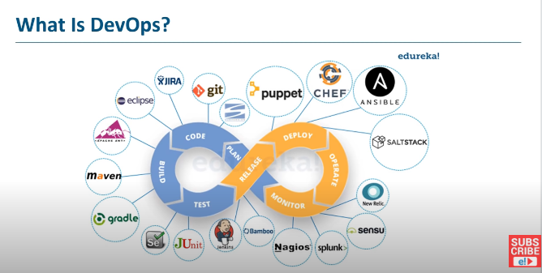

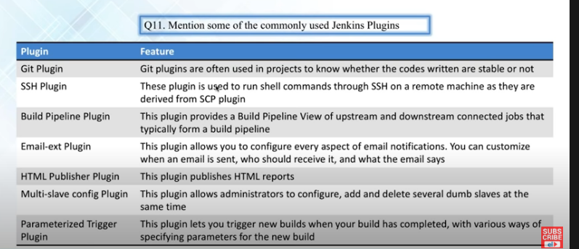

## Agent:

To build your code and deploy your software using azure pipelines, we need at least one agent.

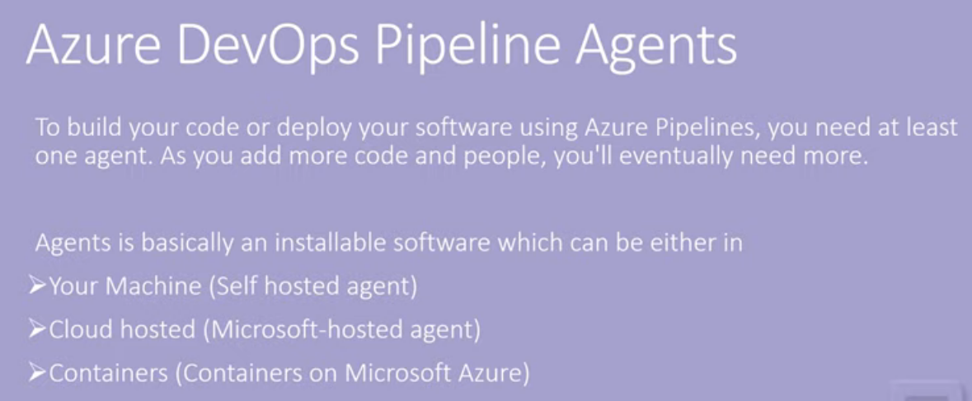

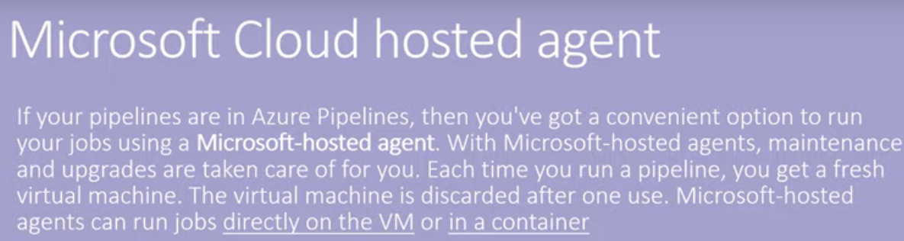

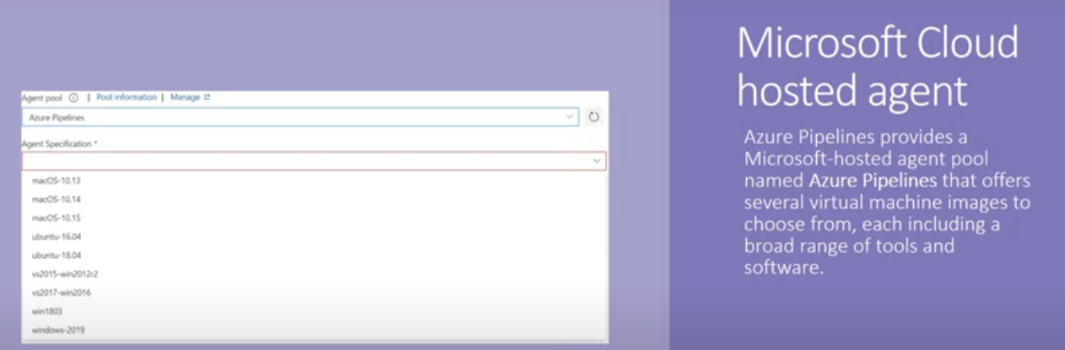

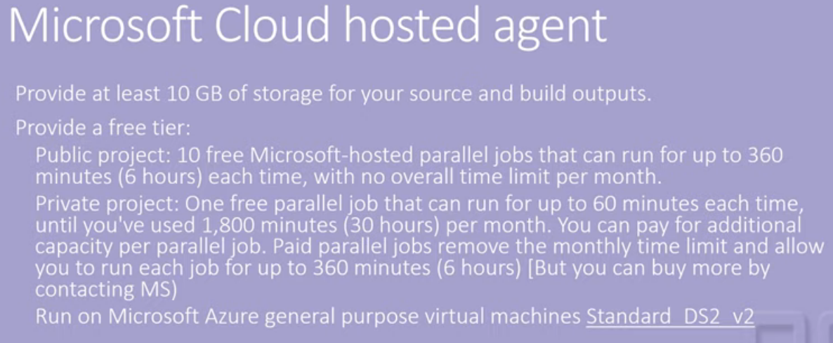

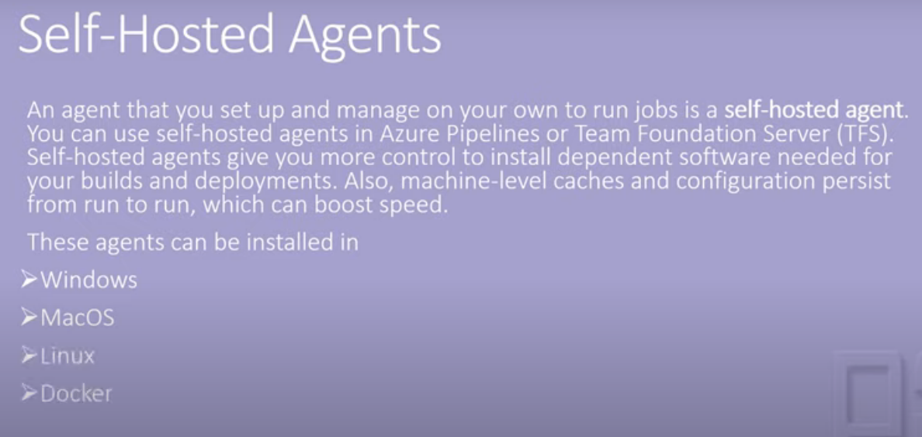

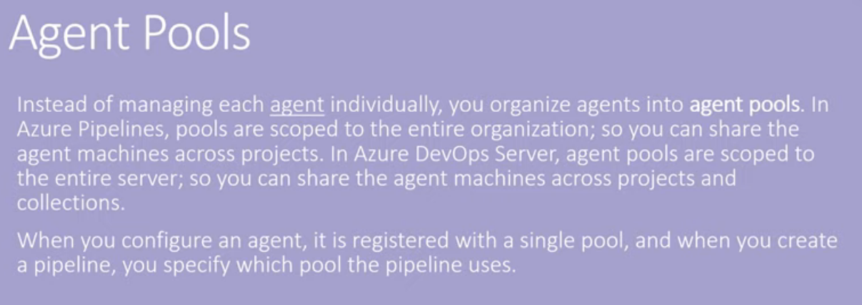

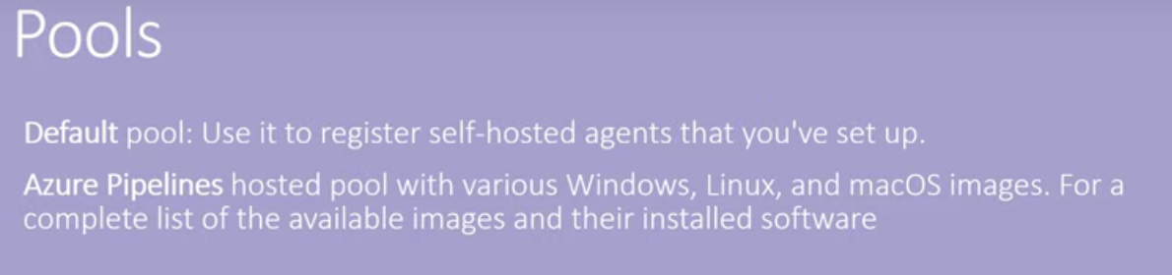

Deployment groups: it represents physical environment for eg. Dev/test/uat

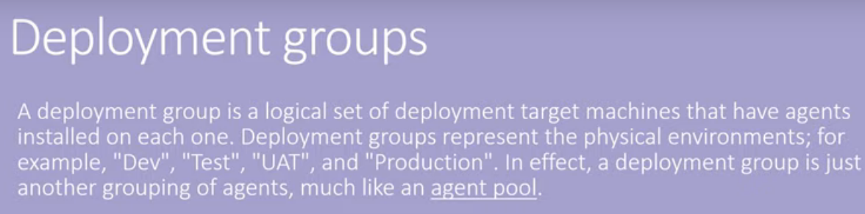

A build agent is a piece of installable software that runs one build or deployment job at a time.

Microsoft hosted agents: MS provided a tool. It will build the VM

Self hosted agents: if MS not provided , then we needs to go for self hosted agents

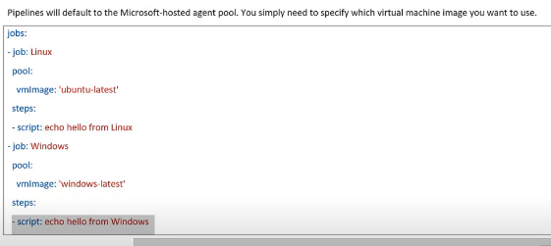

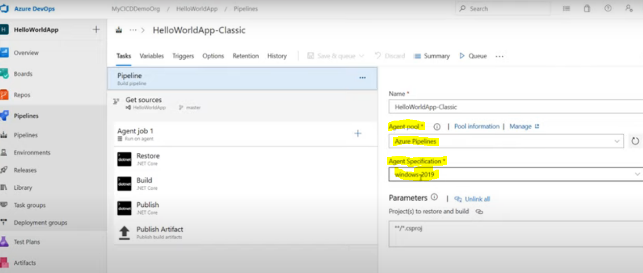

Self-hosted agents: it can have more customization

Agent Pools:

By default ms provide “Azure pipelines” as agent pipeline.

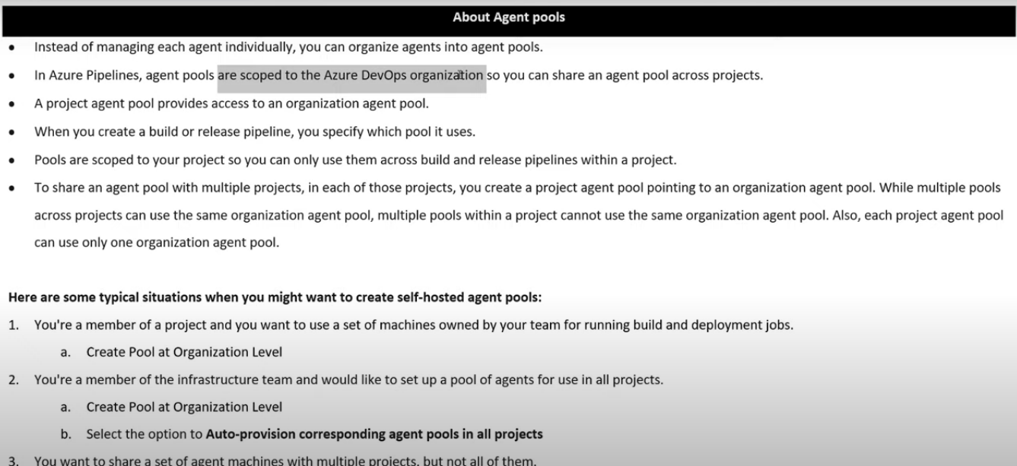

## Deploying on-premises windows machine with DevOps

Solution specify the source code path:

We can also add the tasks. With the tasks for eg fileCoy, we can deploy the files from source to destination in specific path.

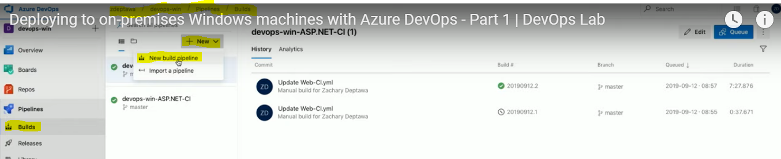

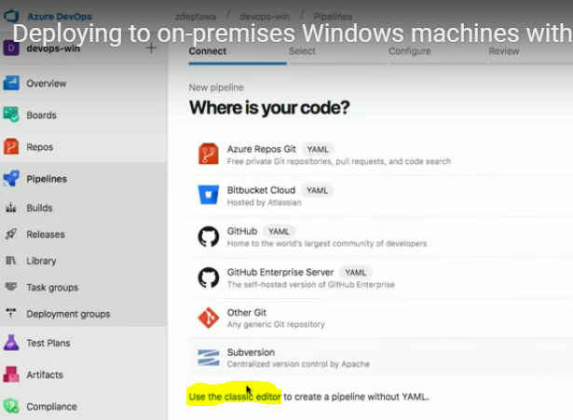

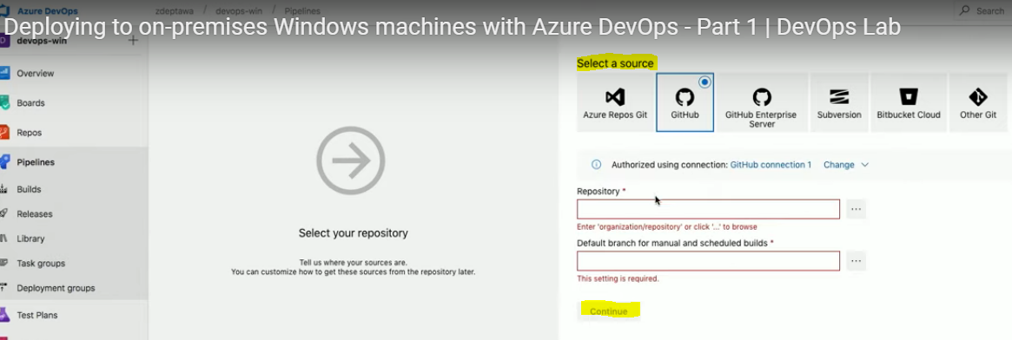

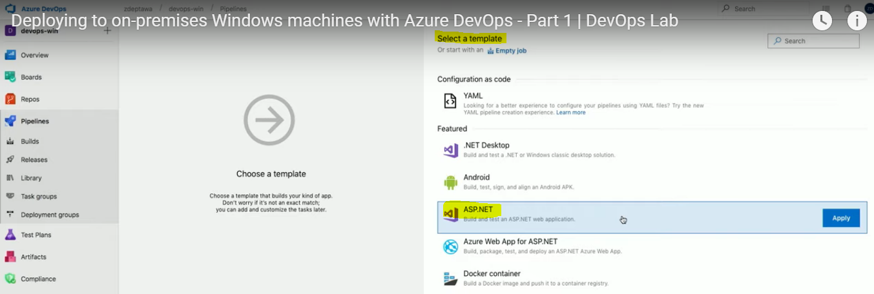

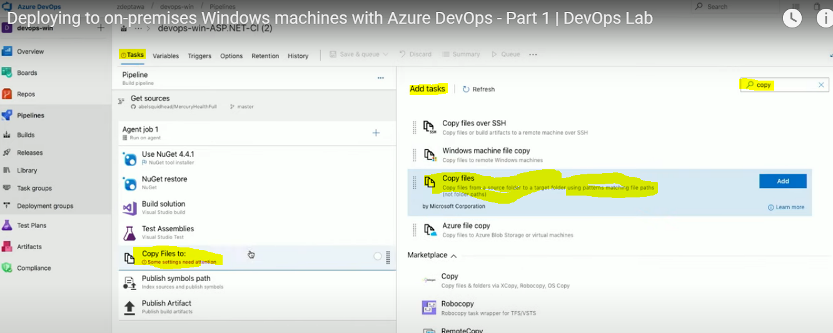

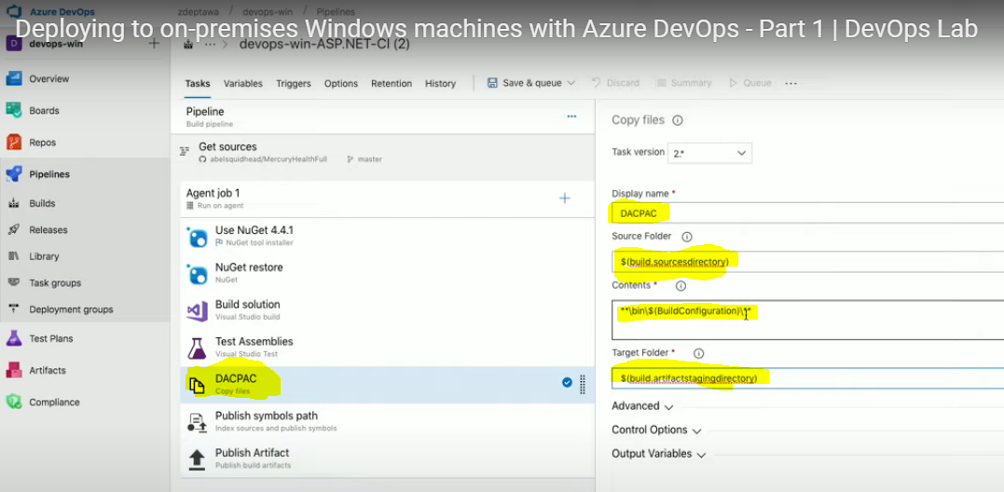

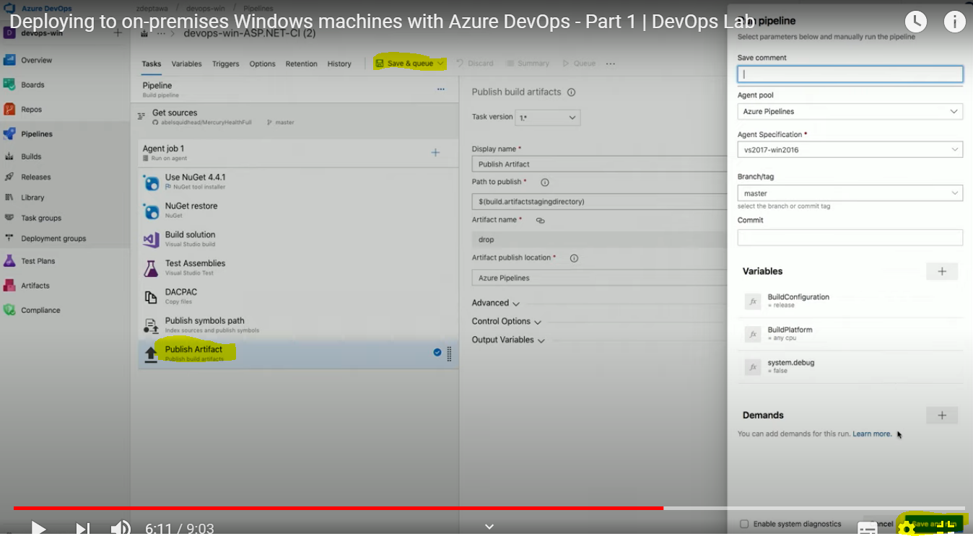

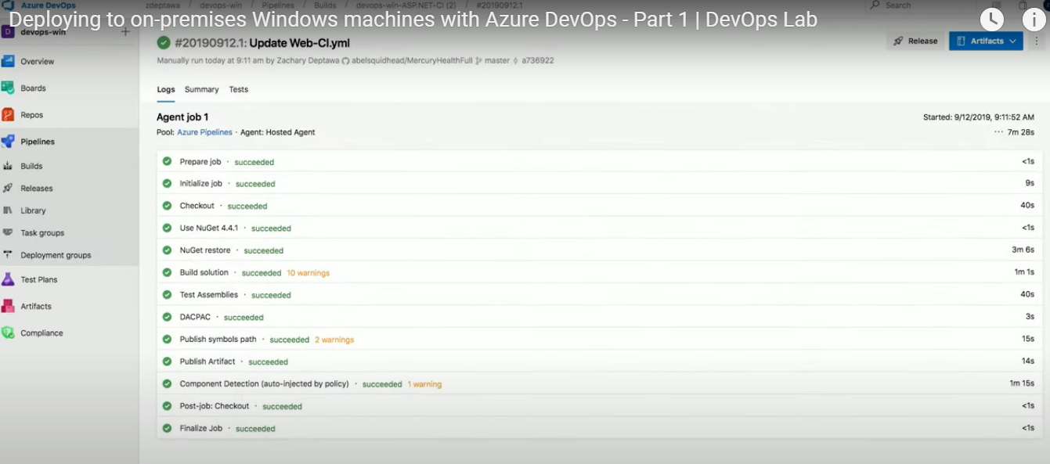

## Deployment group:

If we want to deploy the code in different environments like dev/sit/uat. We needs to create different stages in pipeline. We can also add the pre & post conditions for this tasks eg. Approval. Once everything is fine, we can move the code into different environments.

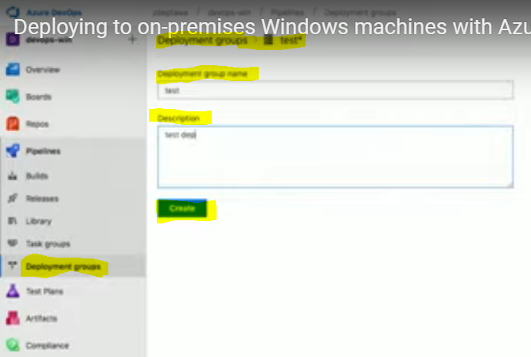

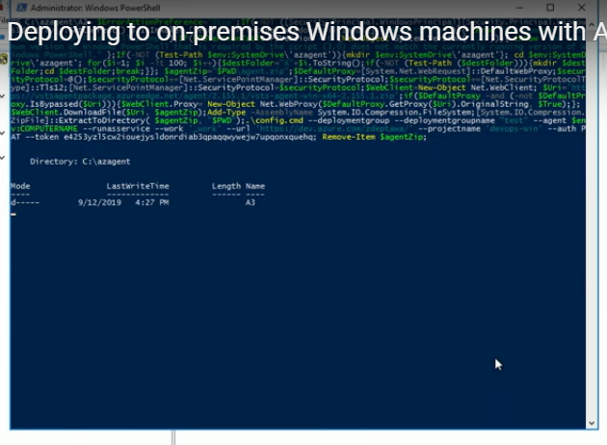

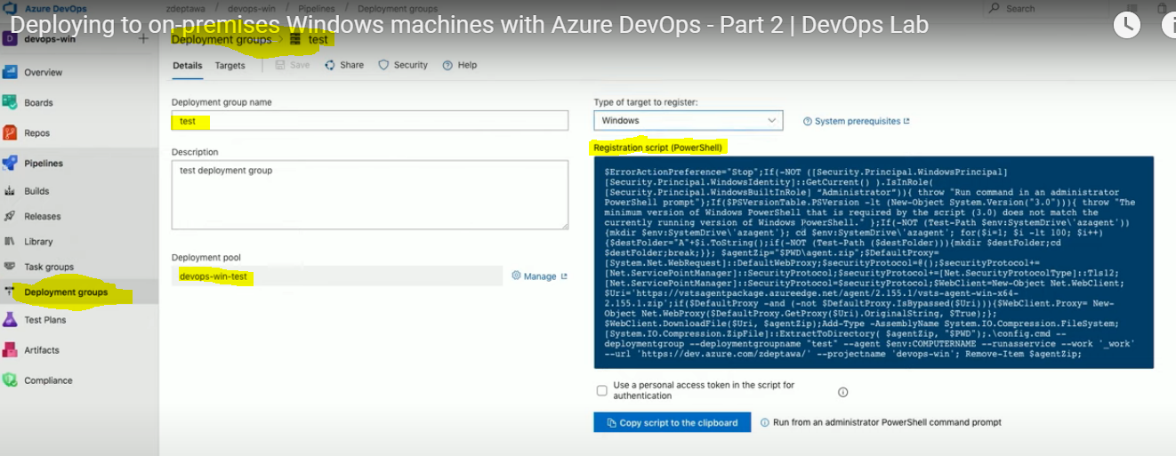

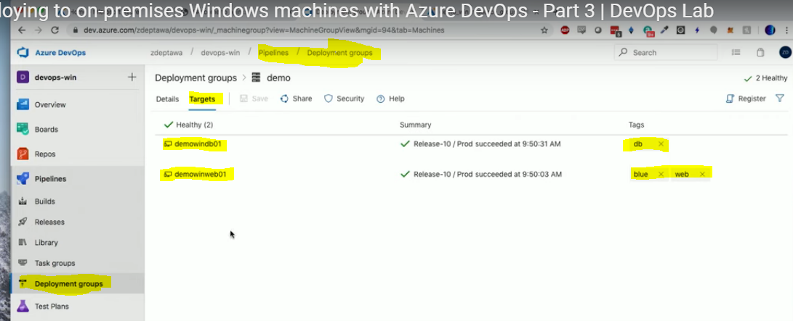

Configuring for different environments in pipeline:

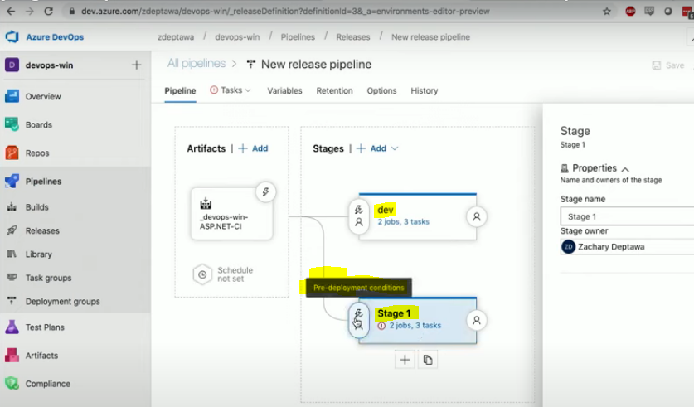

## Service Connection in Azure DevOps:

Service connection helpful

<https://stackoverflow.com/questions/59259493/how-to-create-a-service-connection-for-azure-in-azure-devops-with-pictures>

## Service hooks in DevOps:

**Service hooks** let you run tasks on other services when events happen in your **Azure DevOps** Services projects. For example, create a card in Trello when a work item is created or send a push notification to your team's mobile devices when a build fails.

<https://docs.microsoft.com/en-us/azure/devops/service-hooks/overview?view=azure-devops#:~:text=In%20this%20article,devices%20when%20a%20build%20fails.>

<https://k21academy.com/microsoft-azure/az-400/azure-devops-service-hooks-subscription-of-service-hooks-release-approvals/?utm_source=rss&utm_medium=rss&utm_campaign=azure-devops-service-hooks-subscription-of-service-hooks-release-approvals>

## Azure Messaging: (Event grid, hub, Service Bus)

<https://www.youtube.com/watch?v=-sTMSrPPd9c>

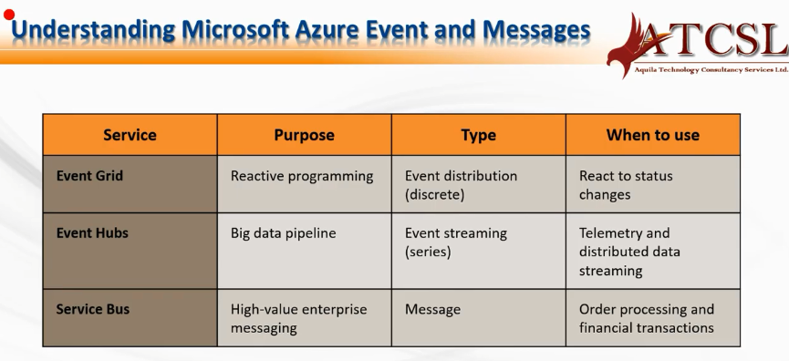

What is the capabilities in self-hosted agent?

How can configure sonarqube in azure pipeline

<https://www.youtube.com/watch?v=lMCg73qsfTg>

Azure migration server from on-premises to cloud

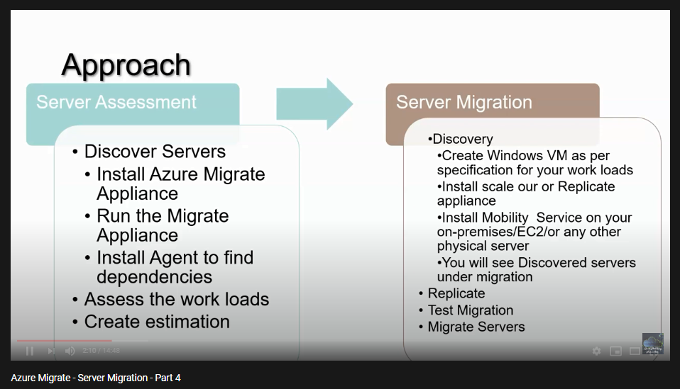

ss

## Migration on premises to cloud:

<https://www.youtube.com/watch?v=qtRwJUhniAg&list=PLMBe3sdy-FxW5_IsHfo-YpMsb0pPF4L75>

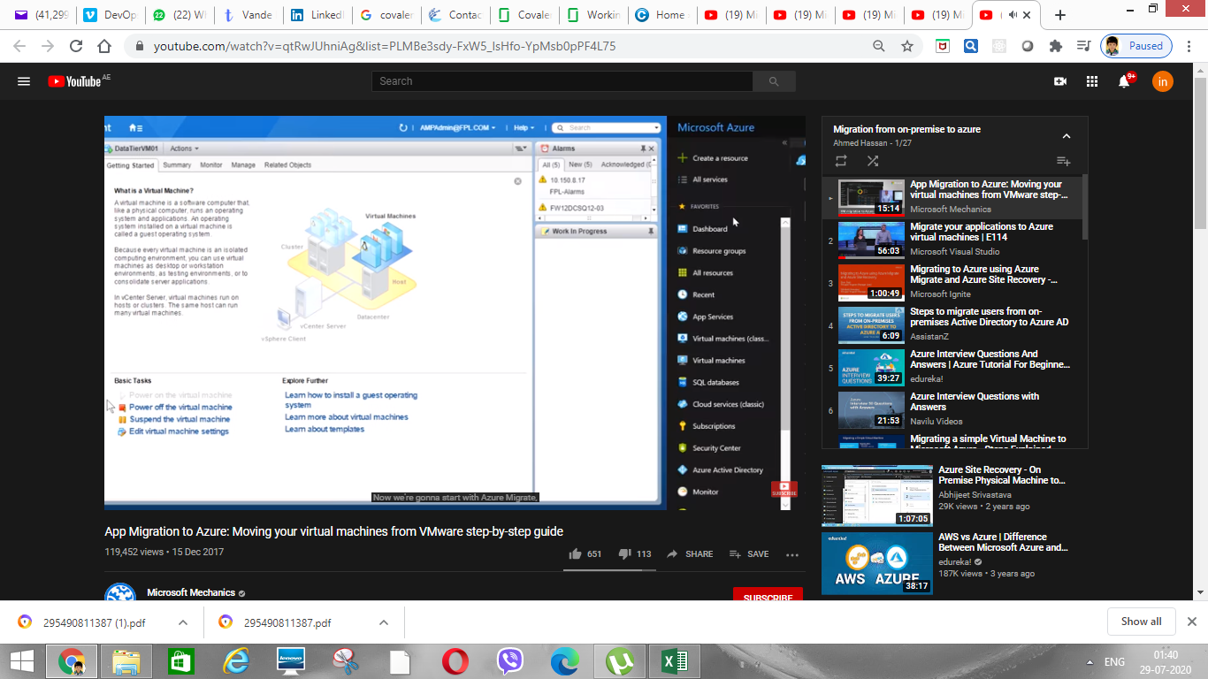

Azure Site recover (ASR) this is primary migration tool.

Its having below steps i.e Discovery, assessment & migration.

Discovery:

Assessment:

Migration:

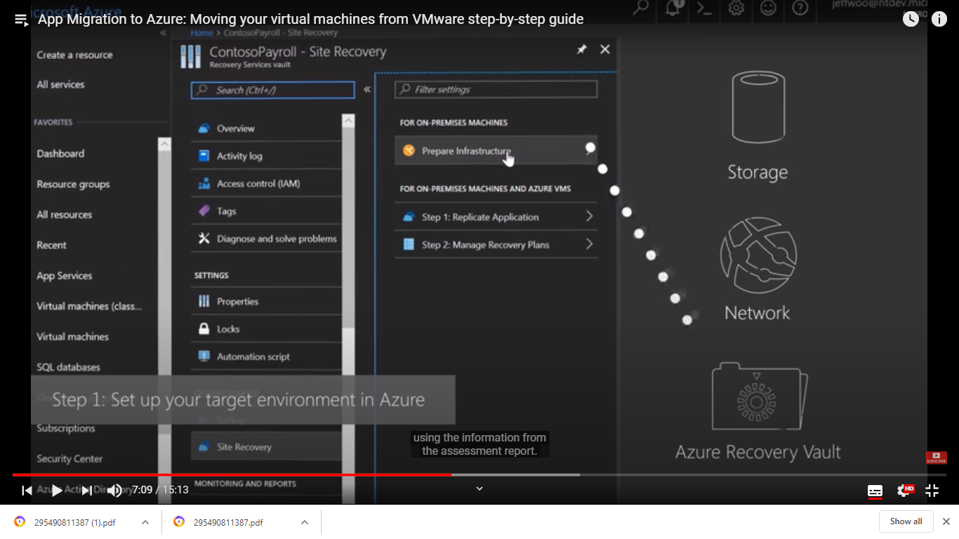

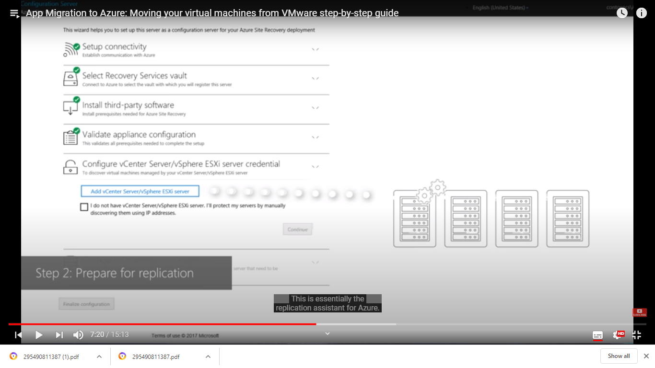

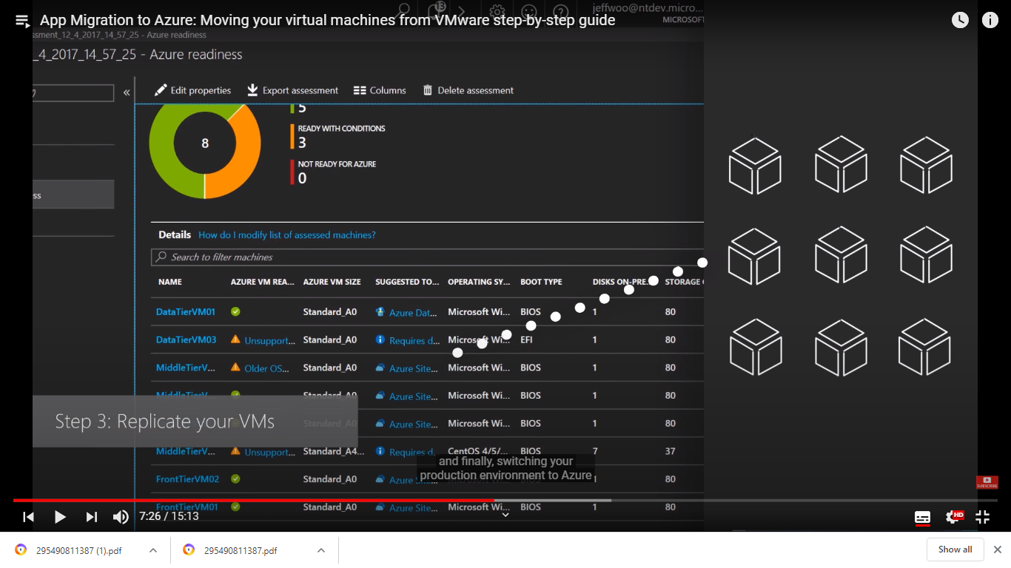

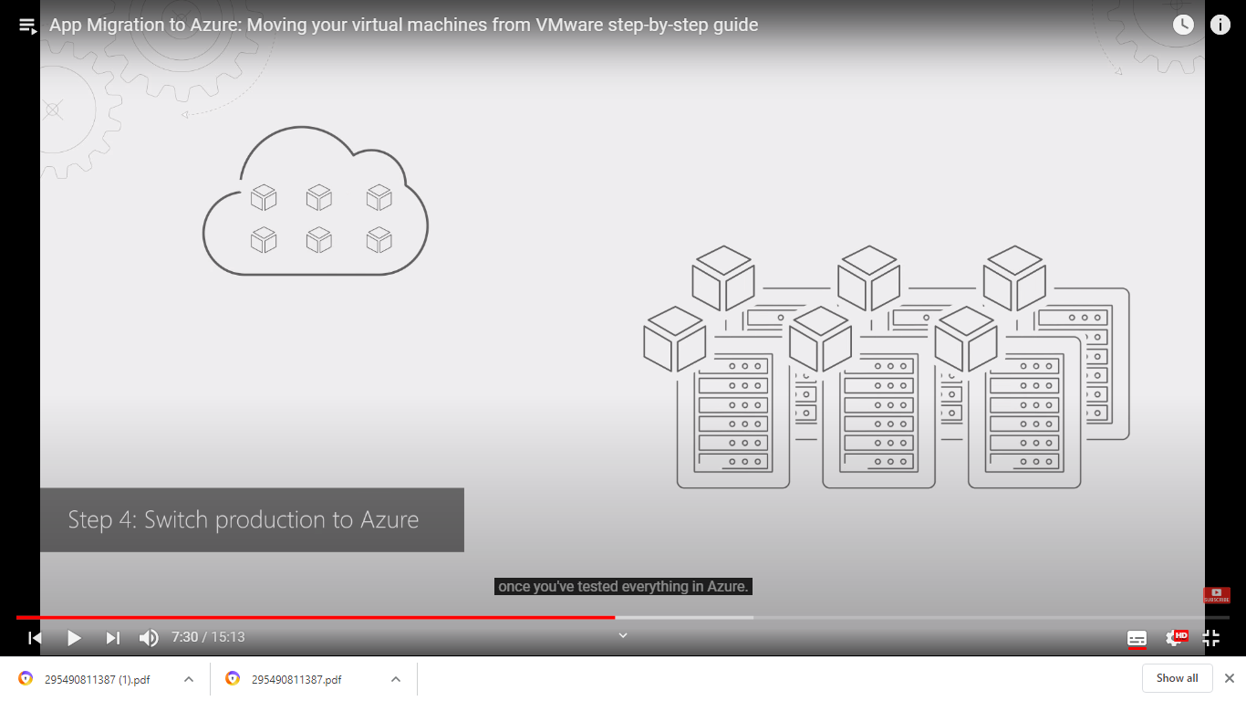

<https://www.youtube.com/watch?v=jo4q-tp9NwM>

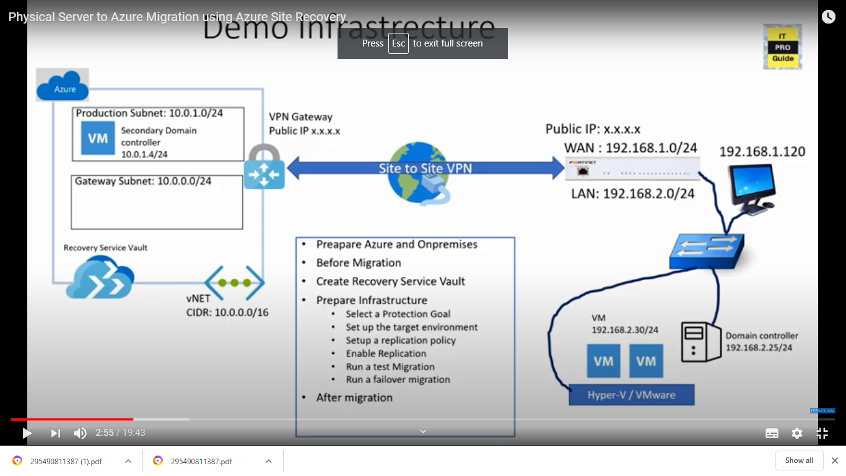

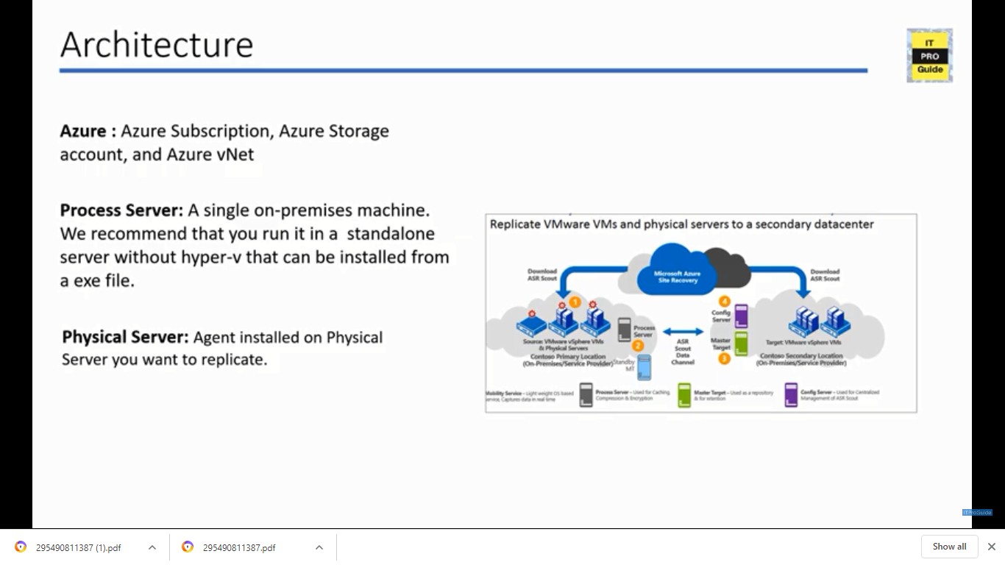

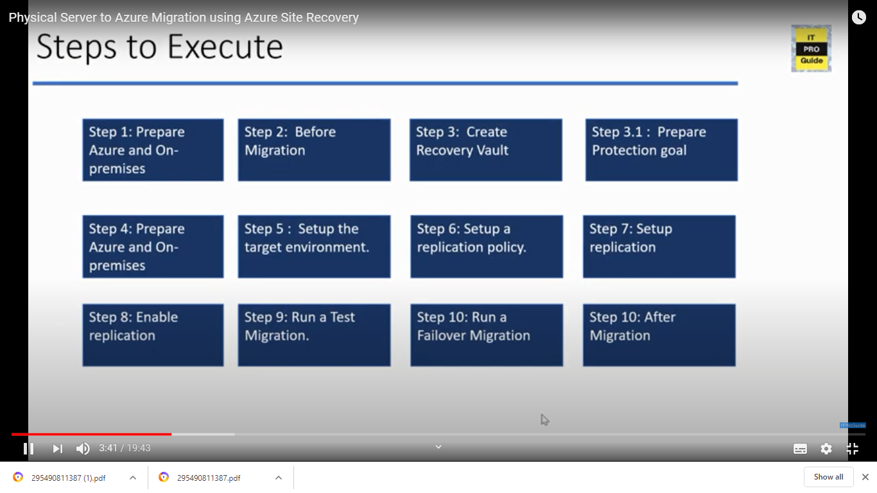

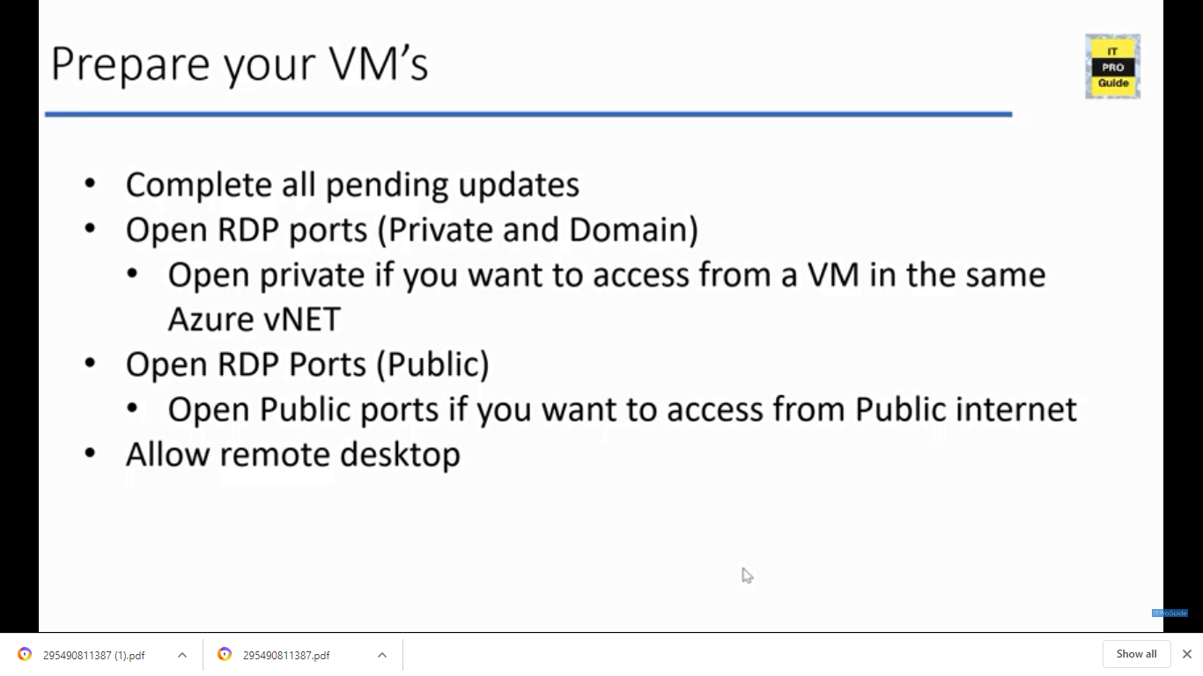

Createate virtual network

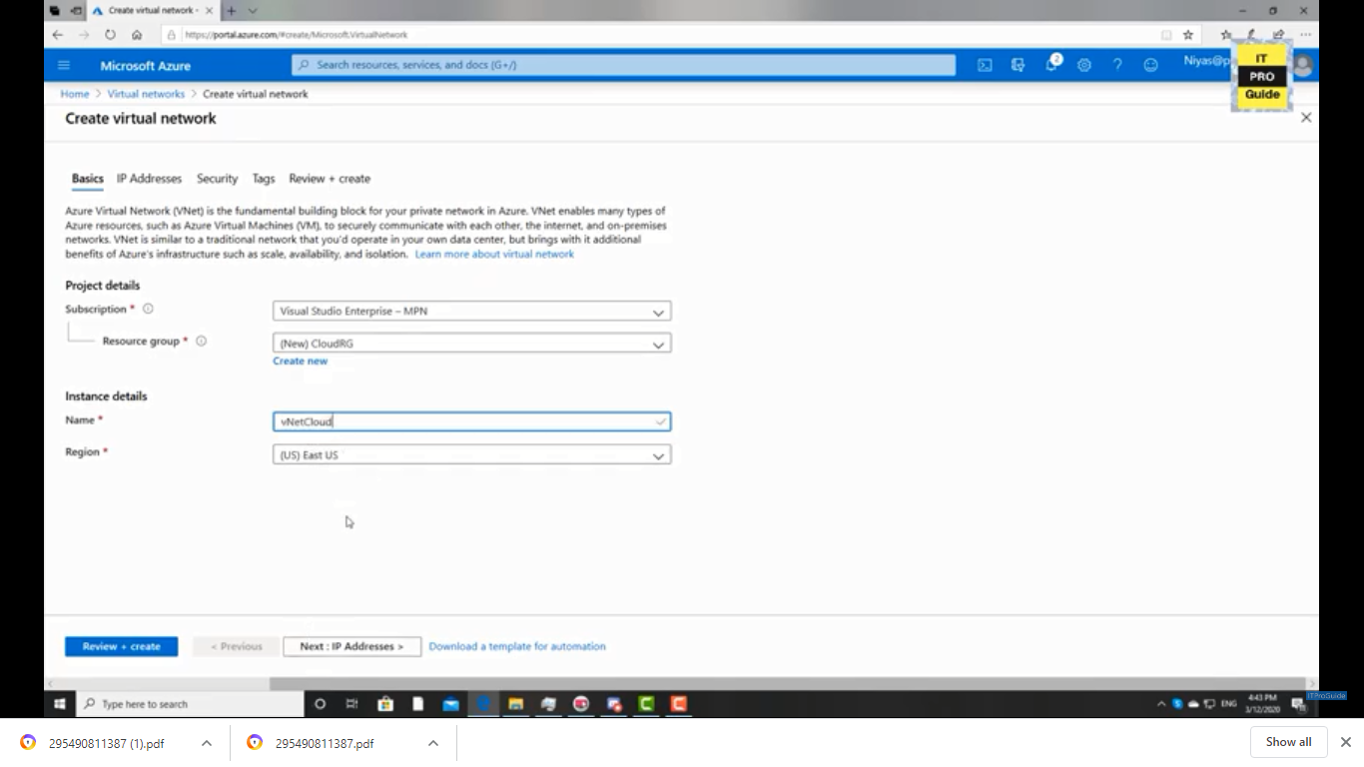

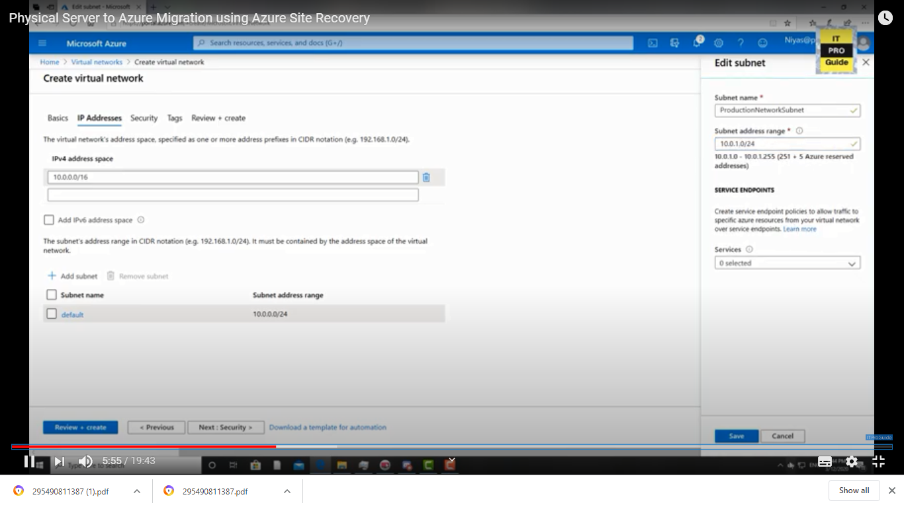

Create service recover vault:

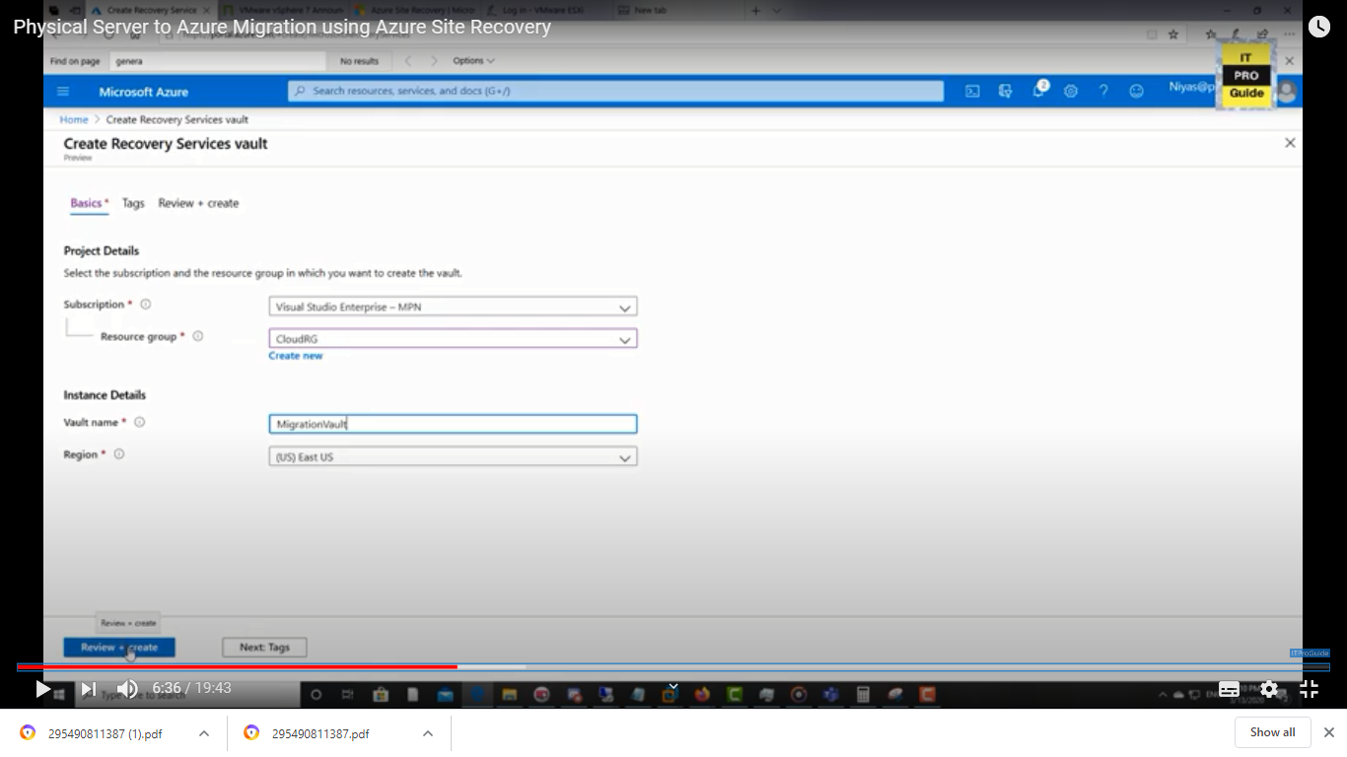

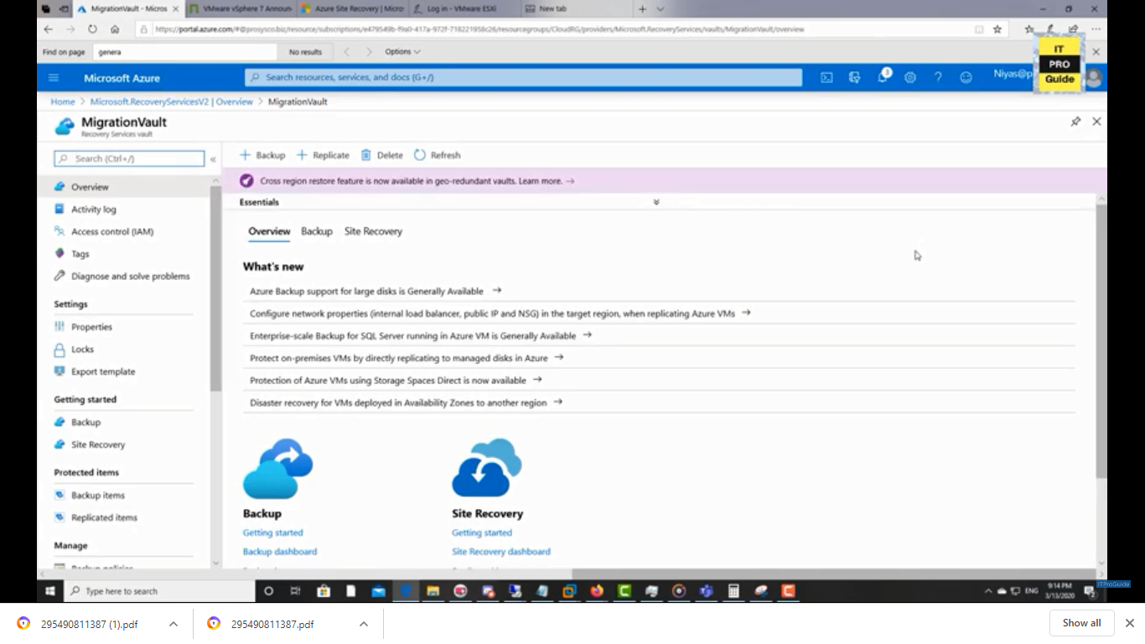

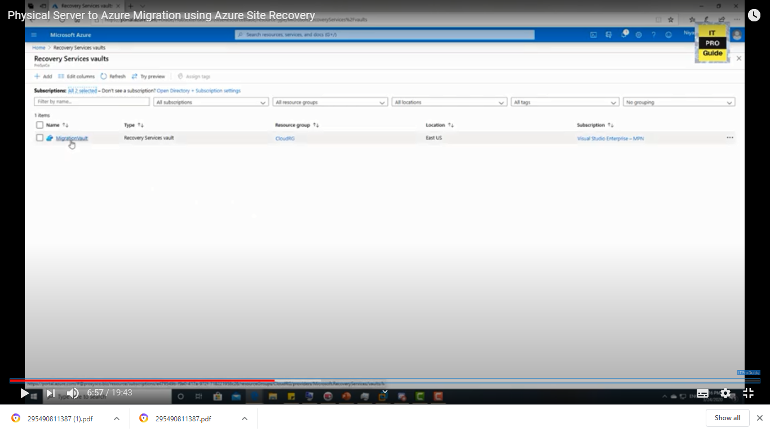

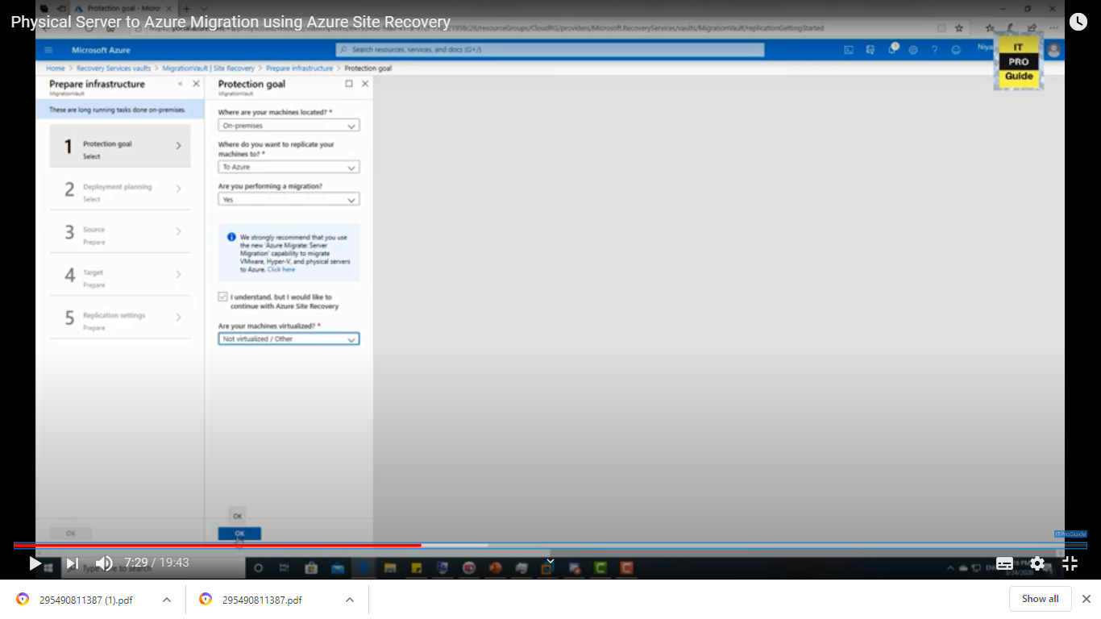

Download the key:

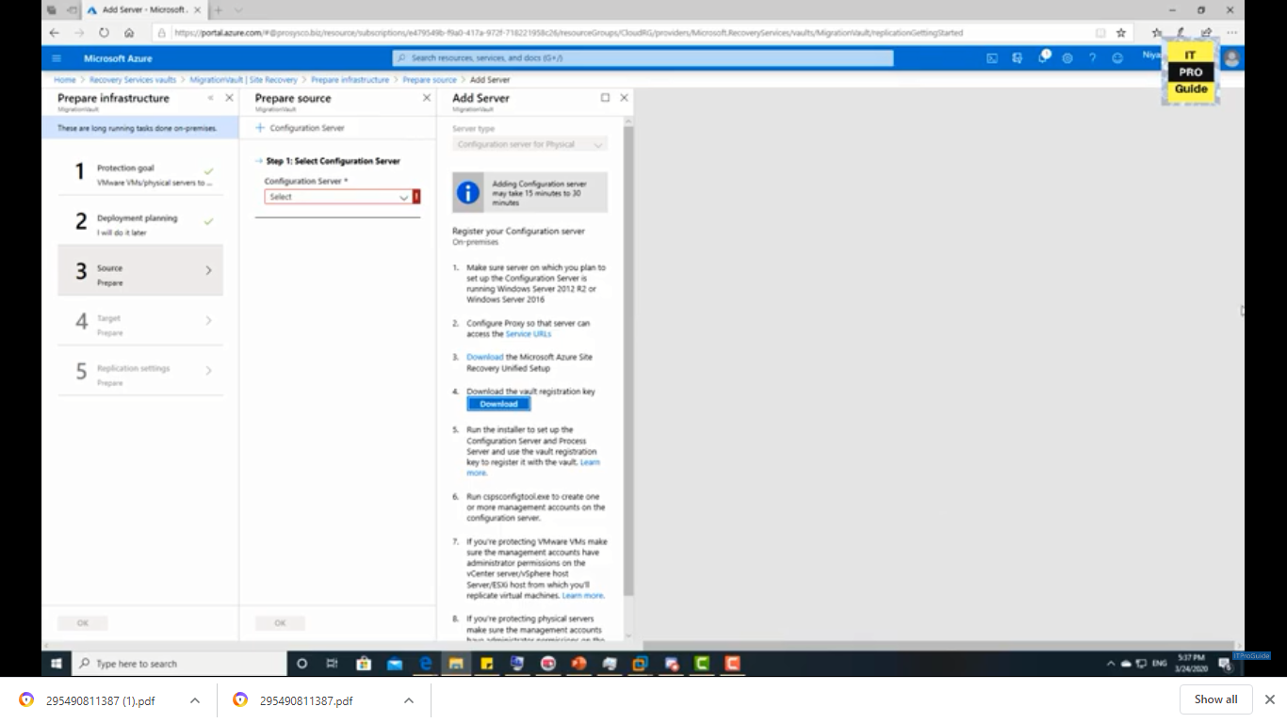

Install “Azure site recovery tool” in the computer

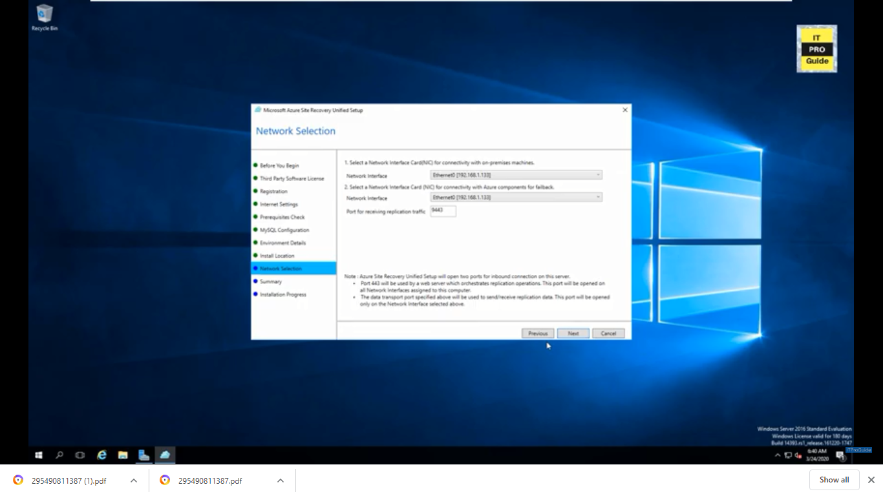

Select configuration server setup:

c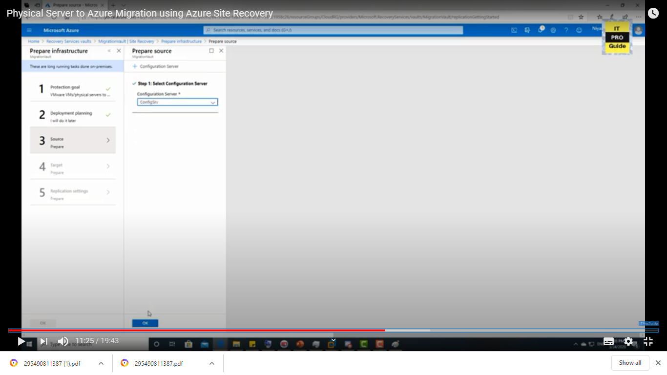

Create replication policy:

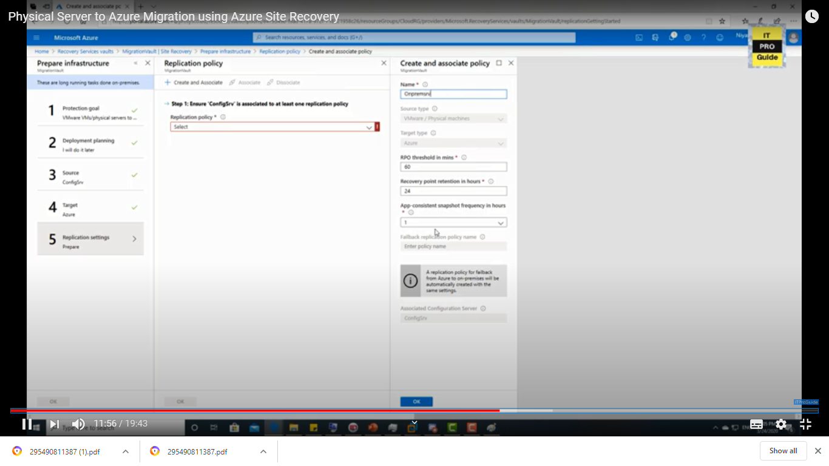

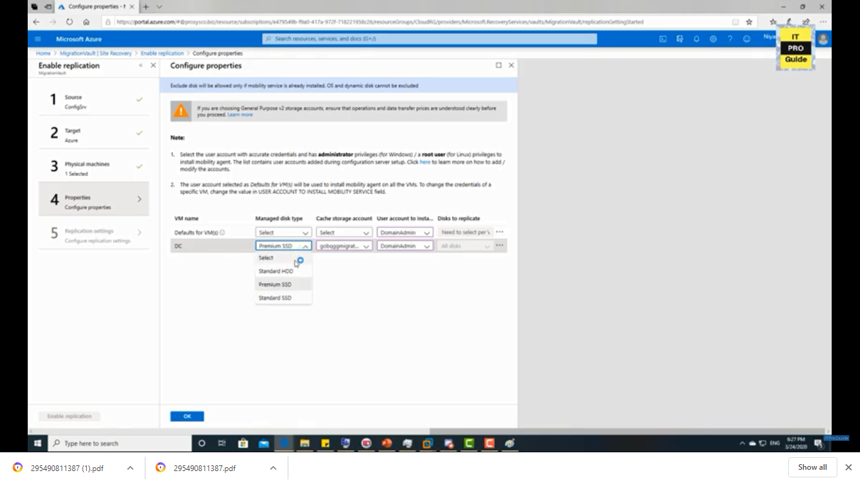

Re run if any test failovers are there

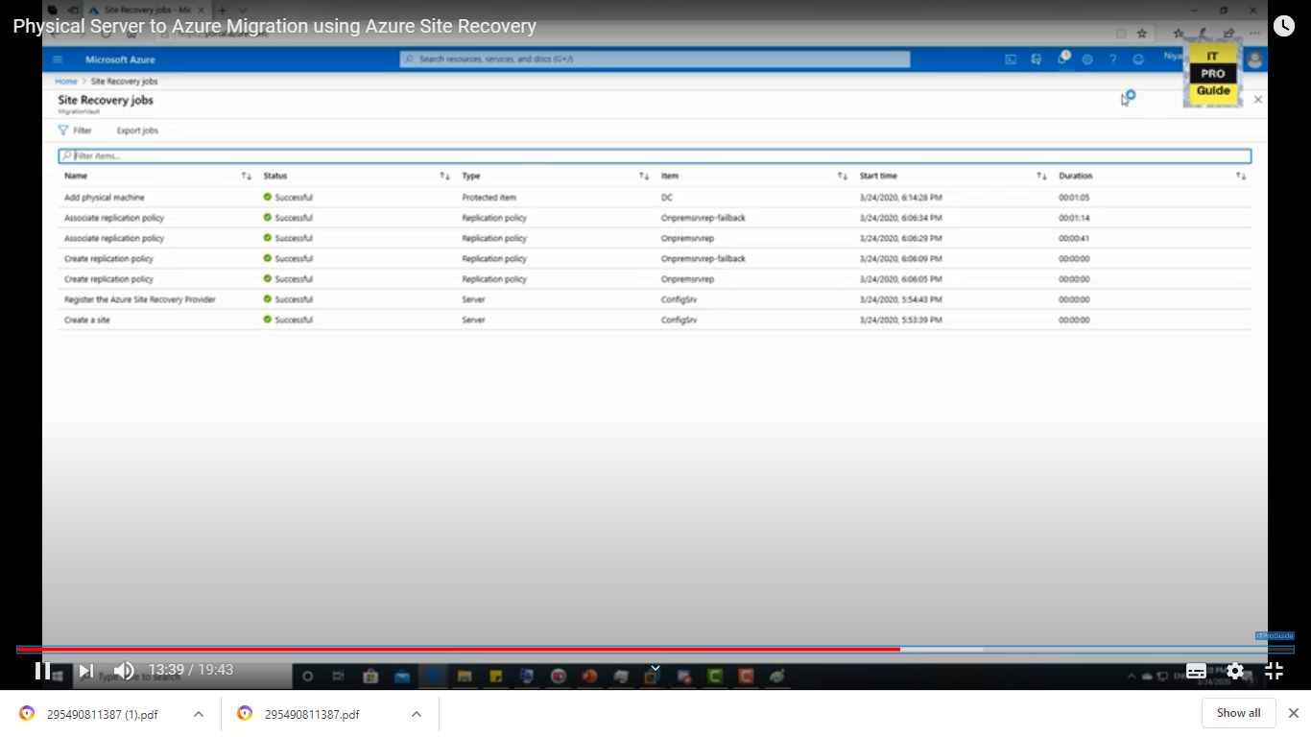

DC-Test is the name which is created vm

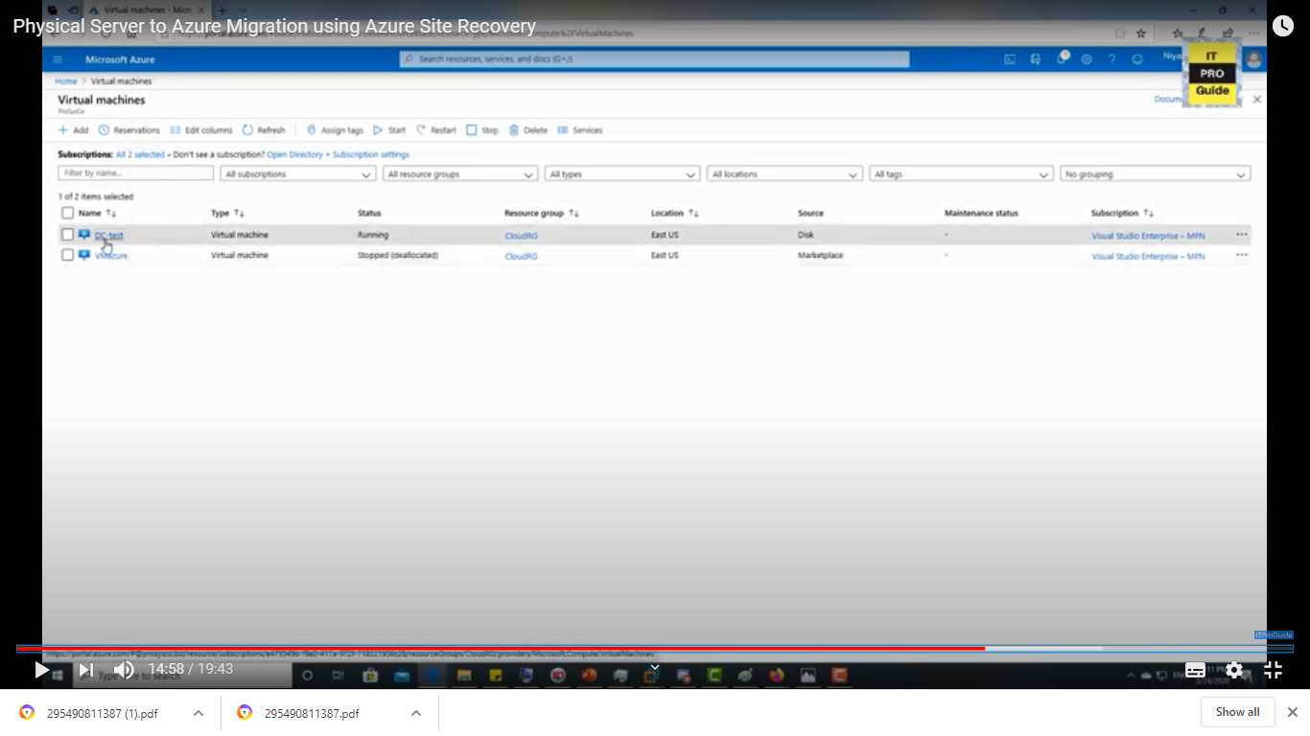

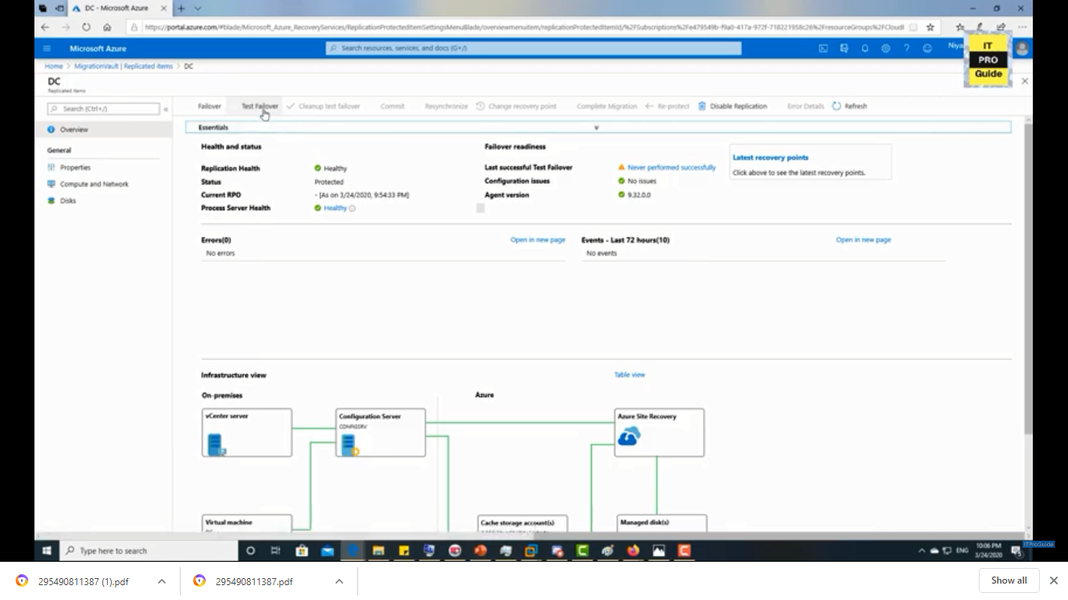

Once test failover completed needs to run failover

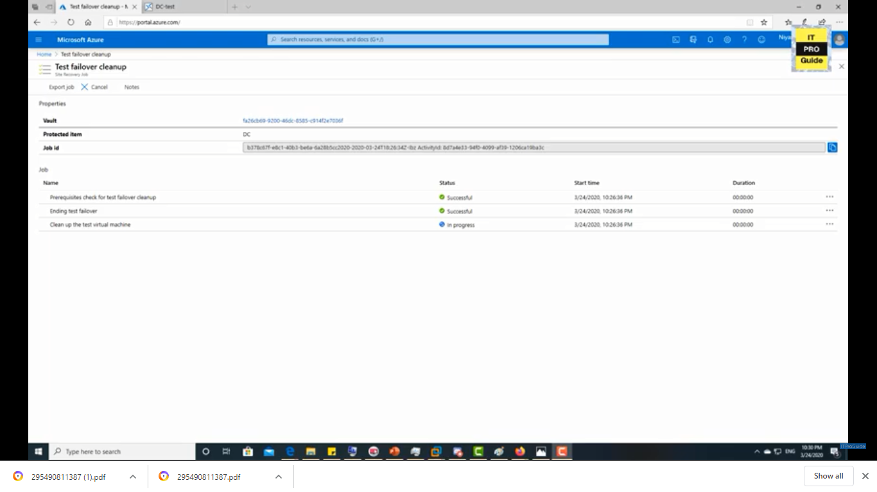

Failover:

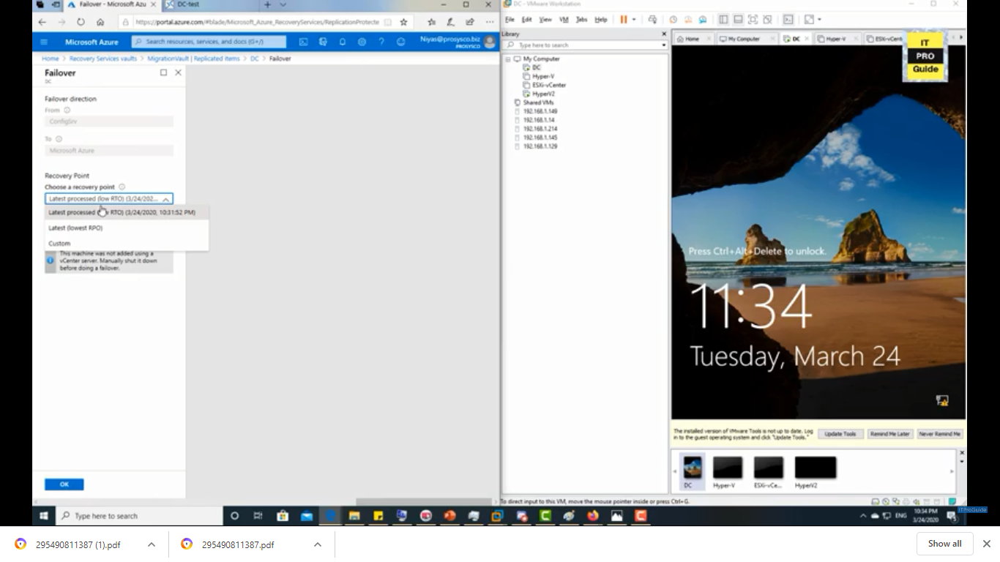

#### Scenario 2:

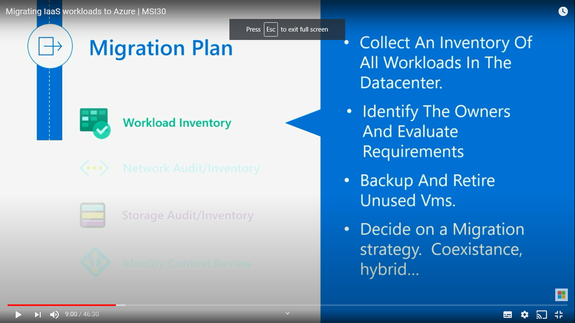

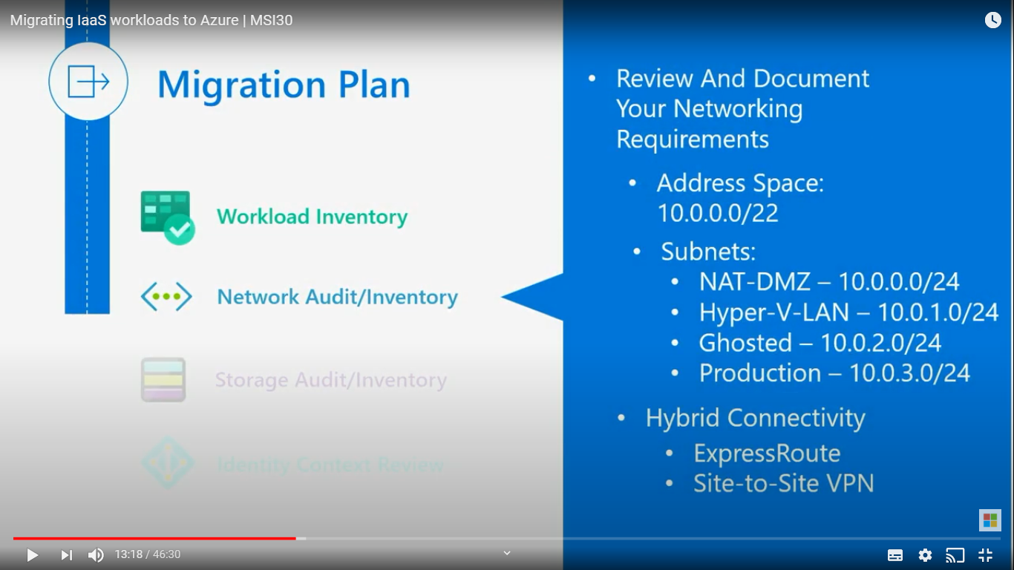

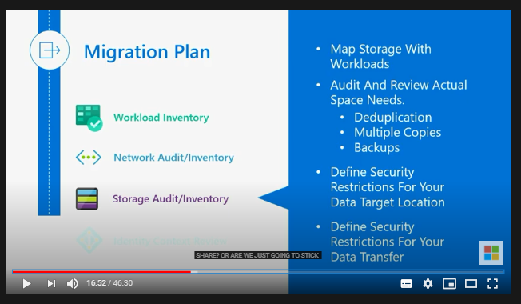

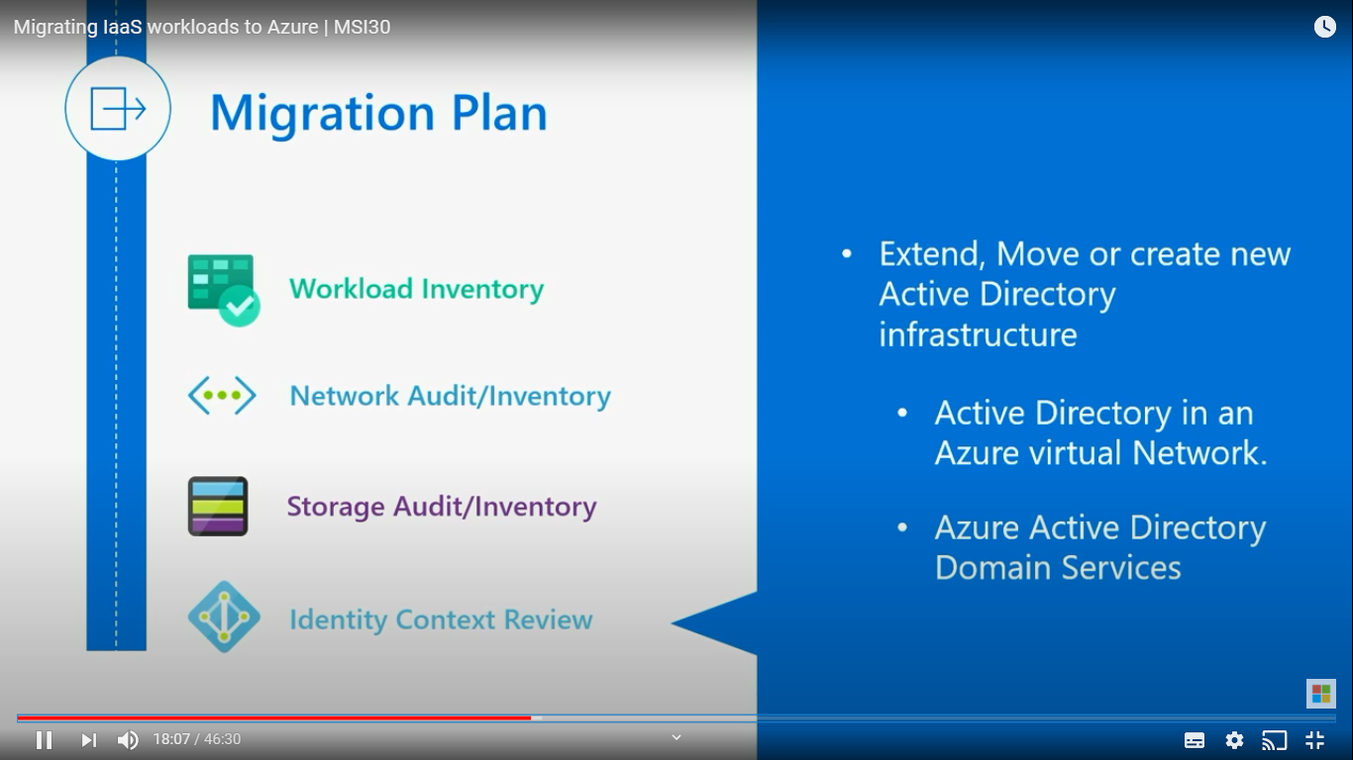

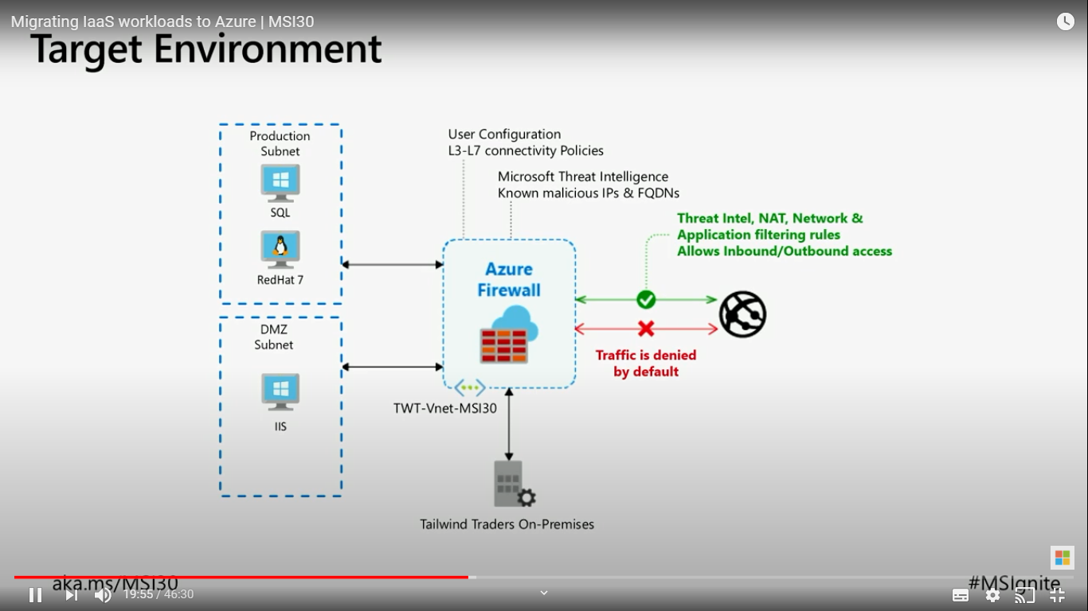

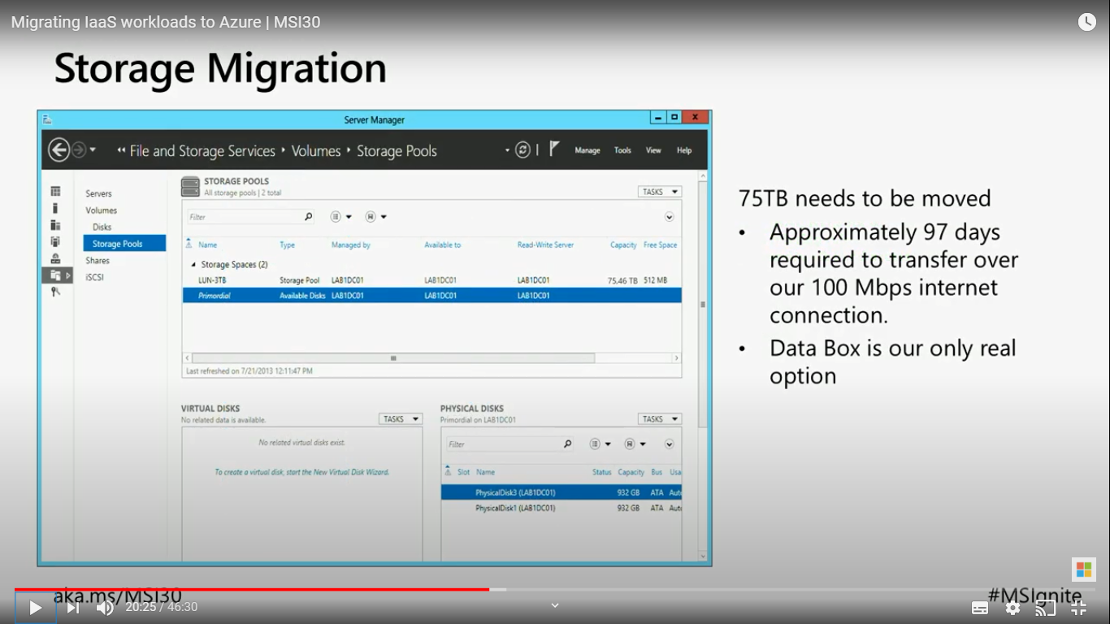

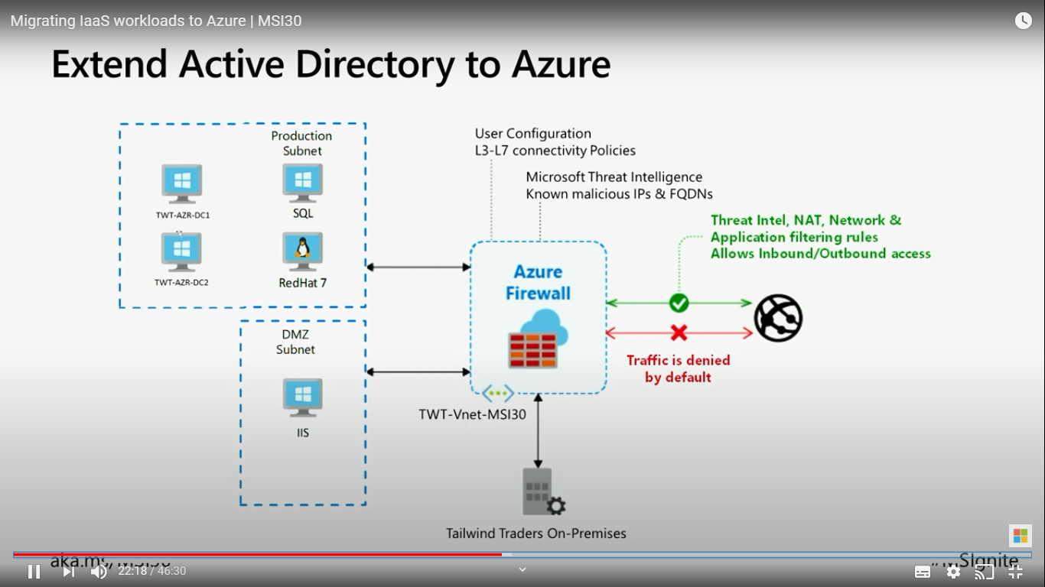

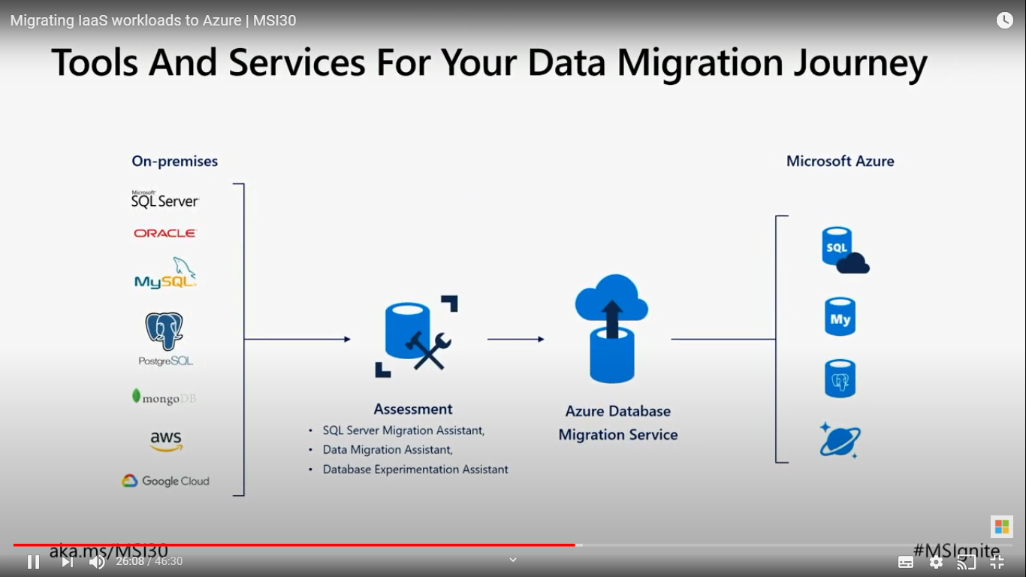

Assessment performing:

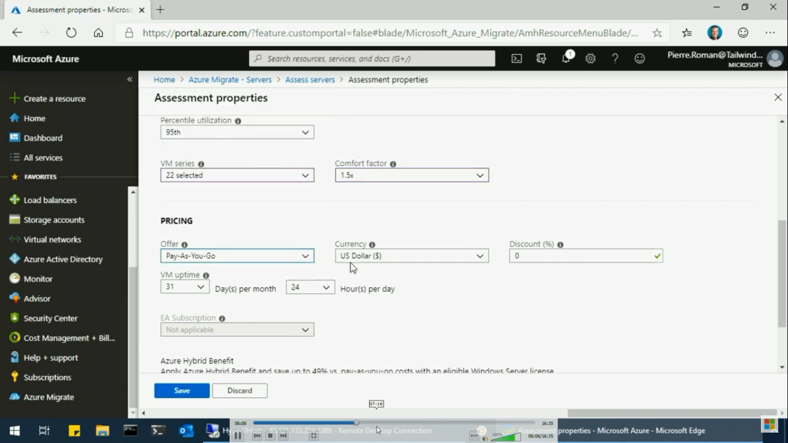

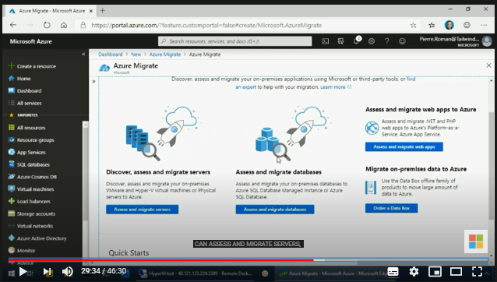

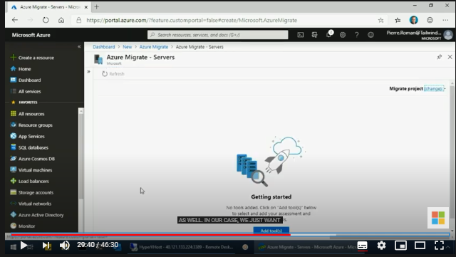

Hyper v Migration:

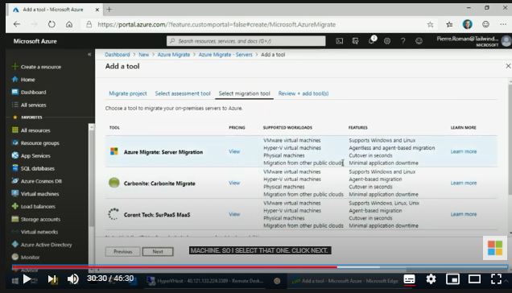

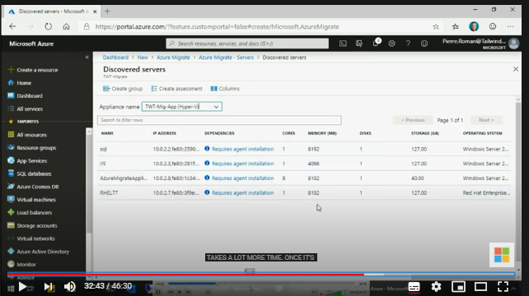

Discover dependencies:

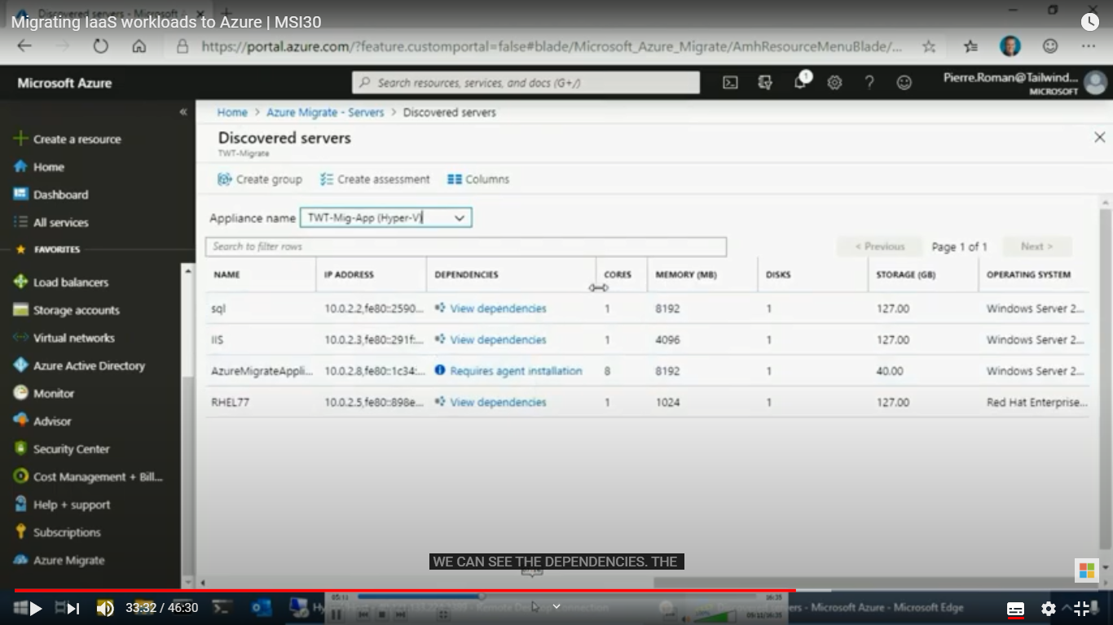

Later needs to do assessment, to identify the size and pricing of the VMs and re

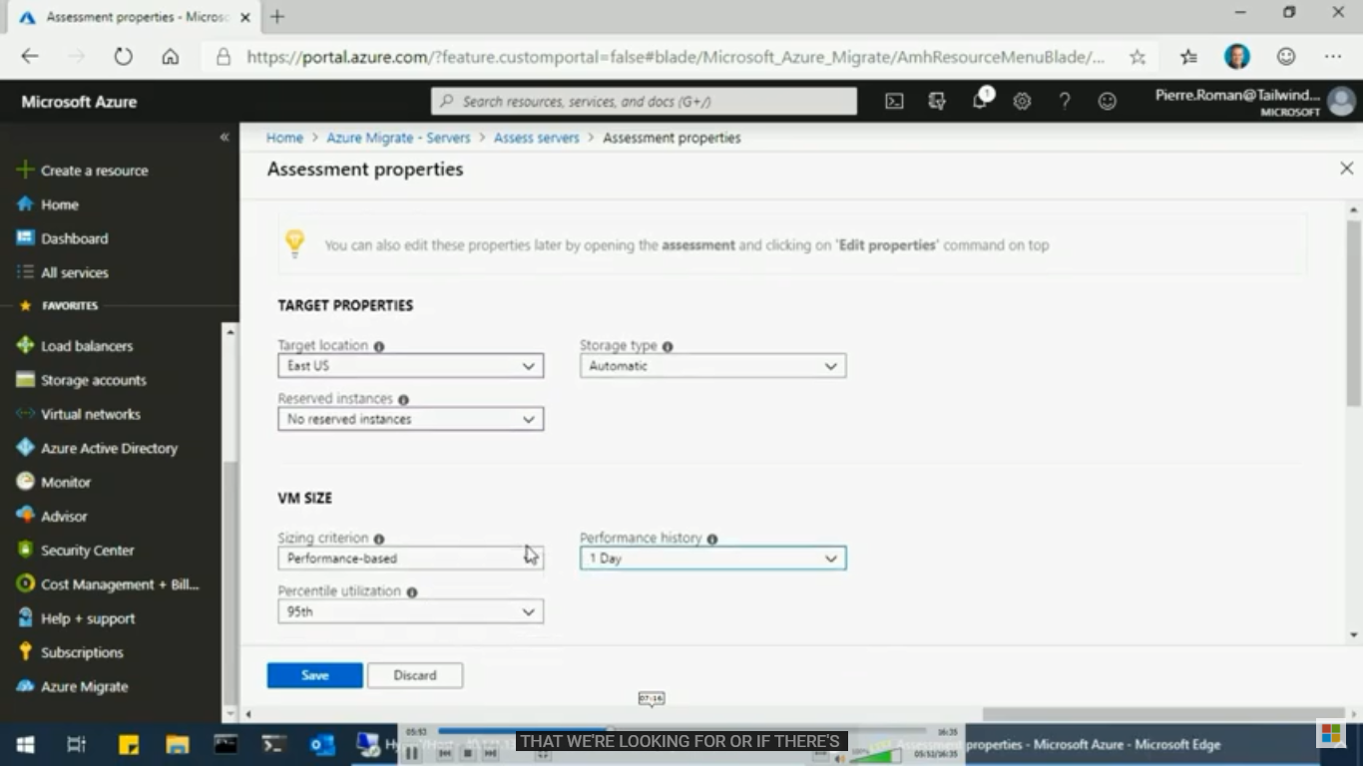

Dependencies: below screen shot displaying dependent servers

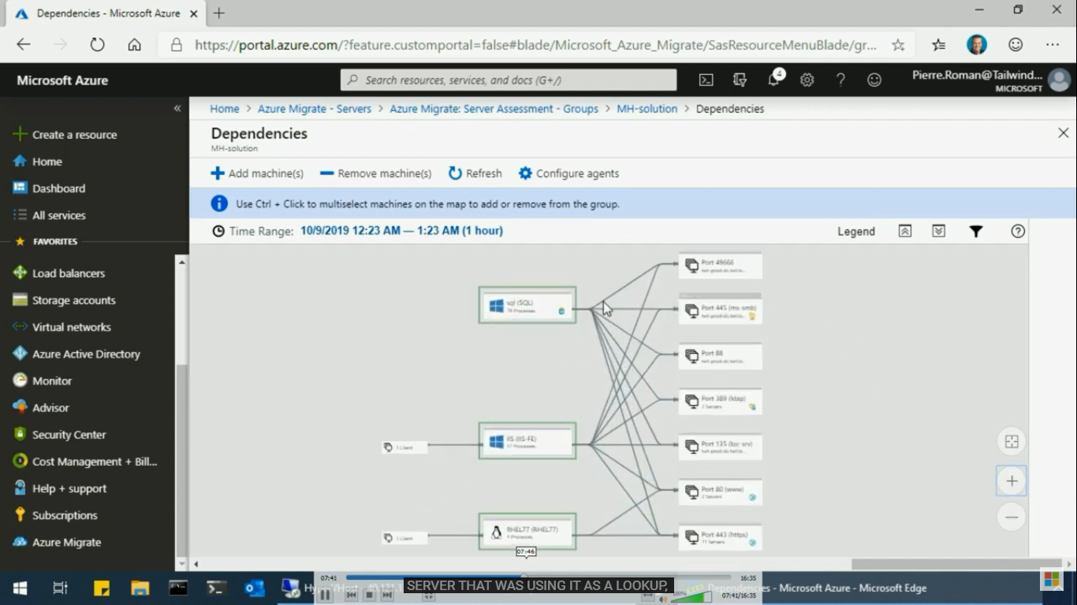

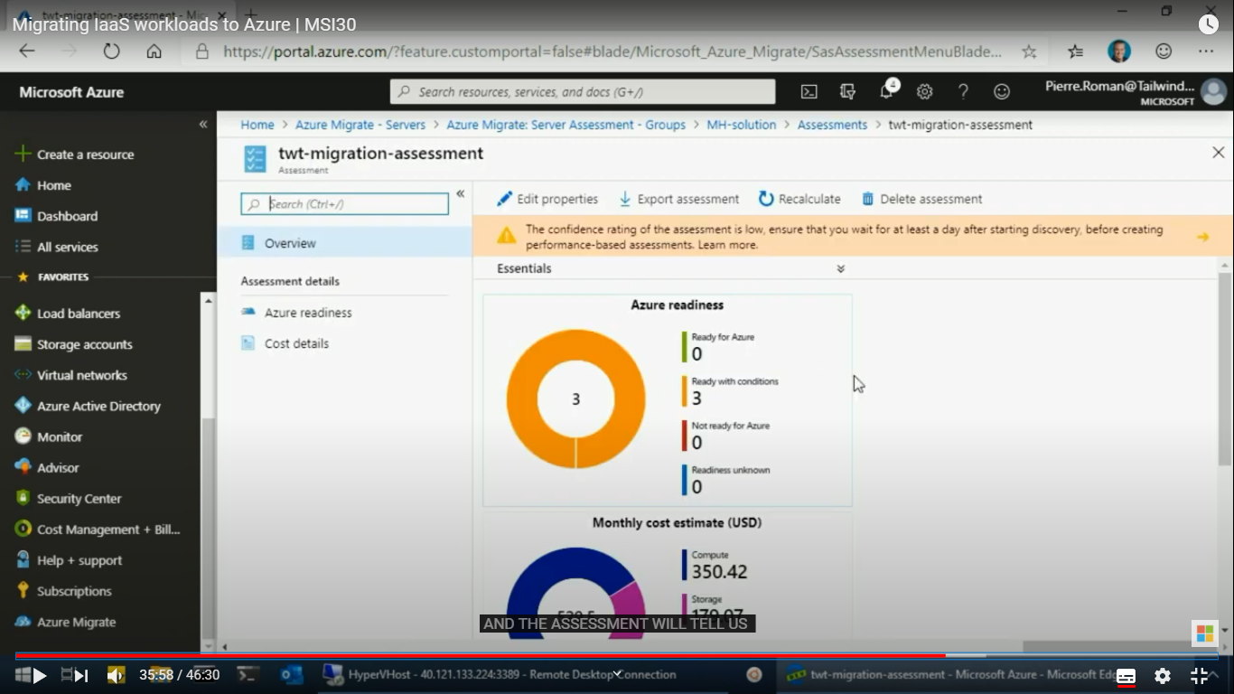

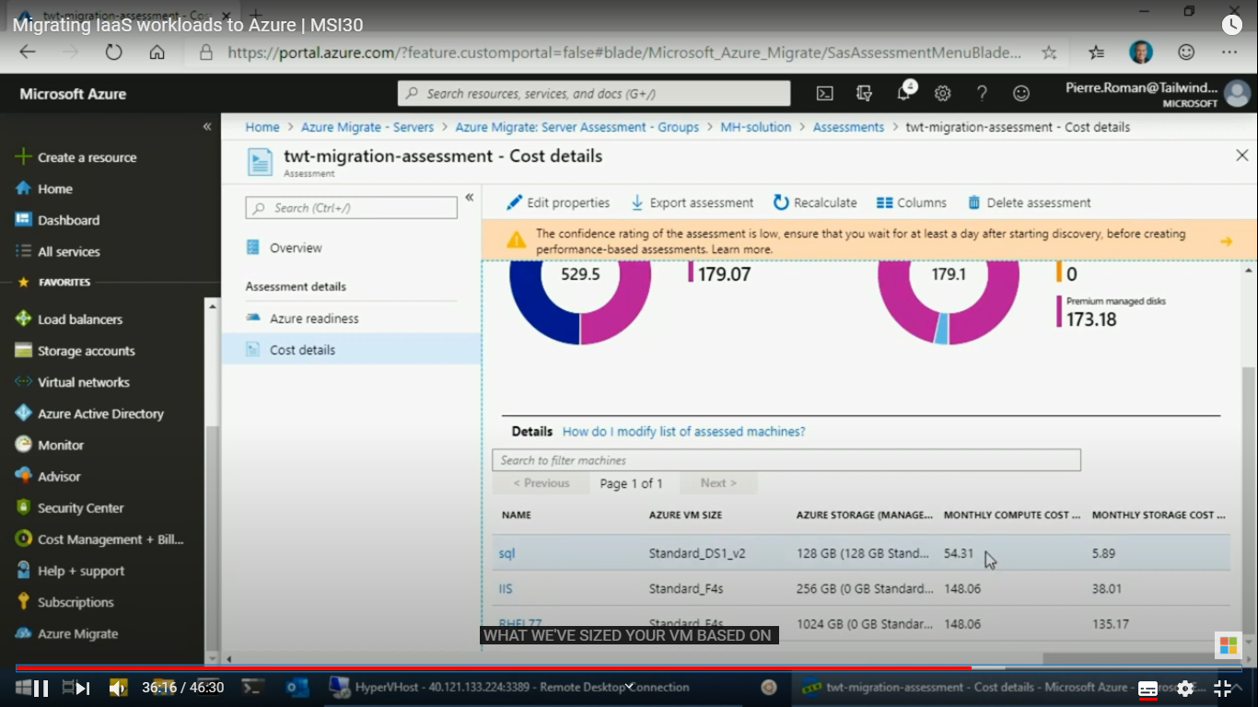

Azure site recovery tool

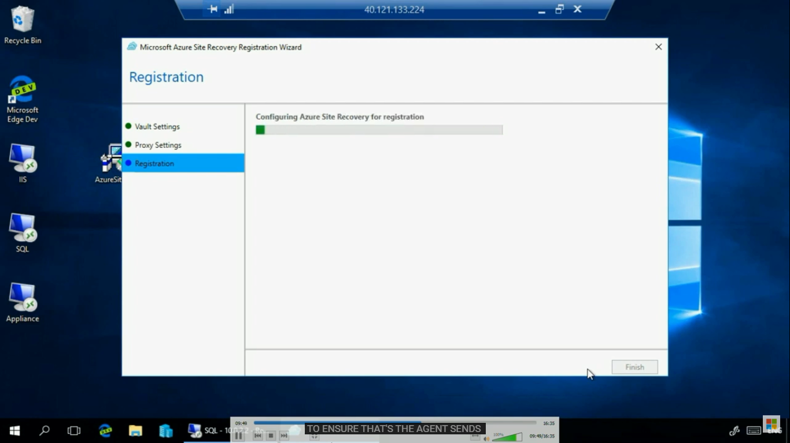

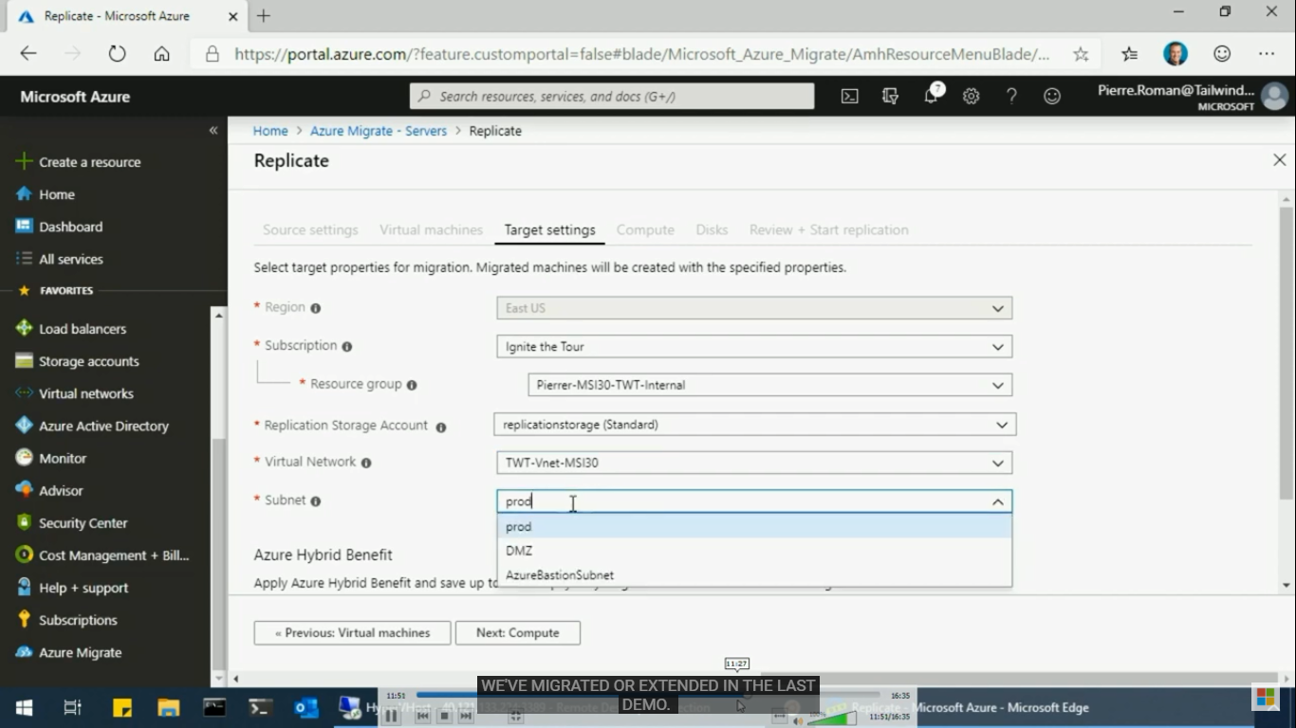

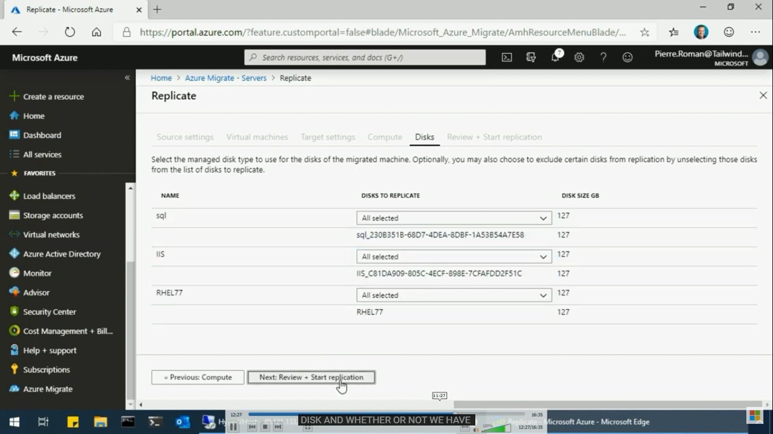

Test migration:

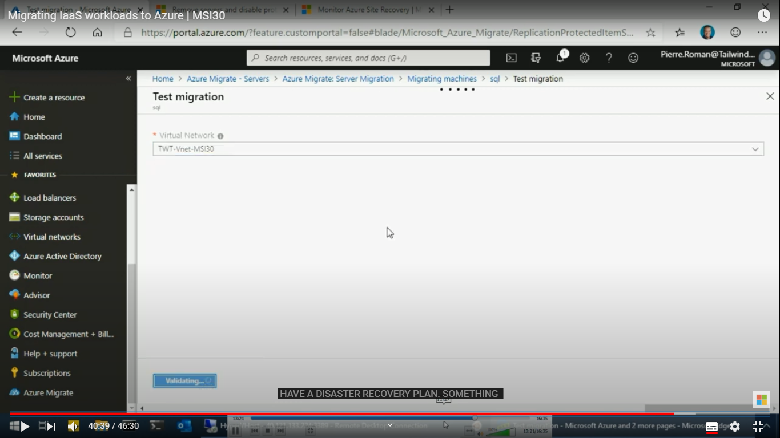

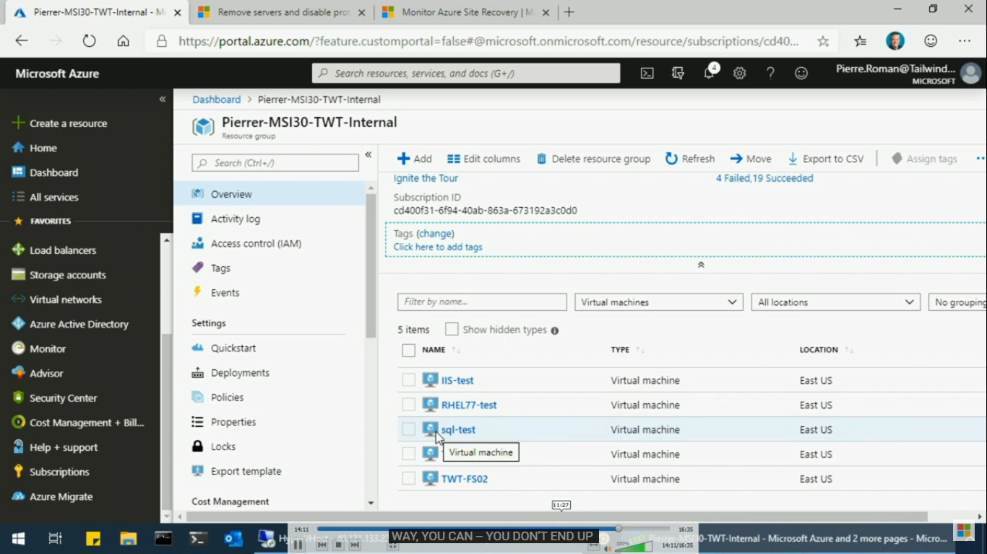

Clean up test migration:

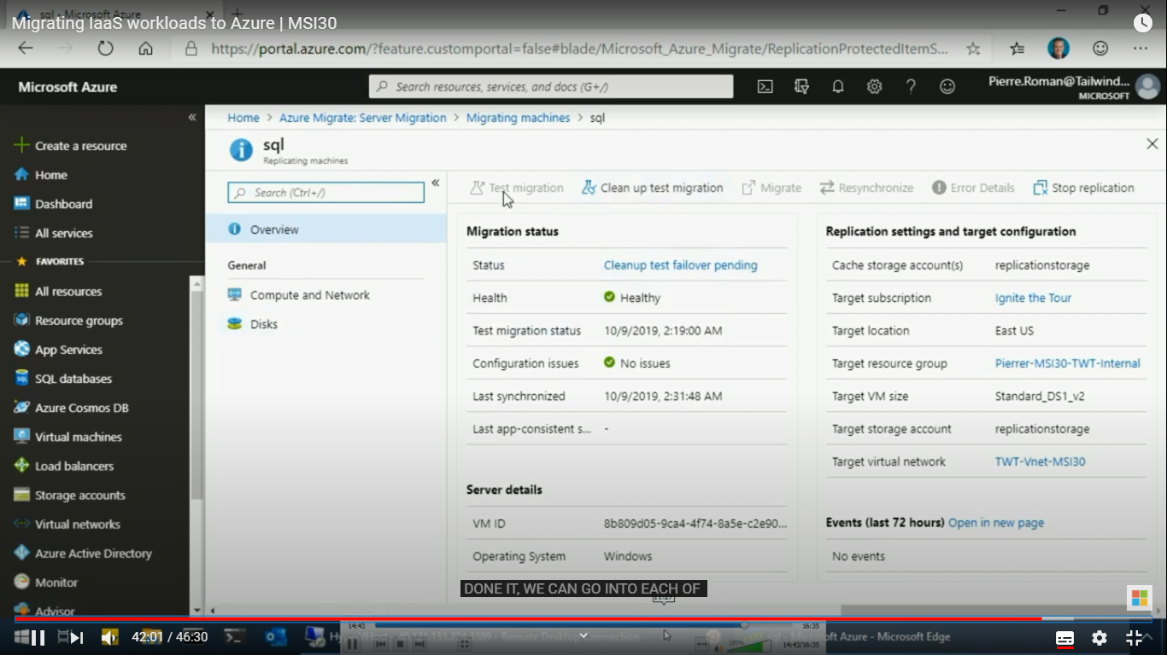

Real migration:

